# Introduction to MEF

## What is MEF

MEF stands for Managed Extensibility Framework.

You can build composable applications and extends them using MEF

MEF is a framework that simplifies building extensible applications using dependency injection based component composition and other features that support modular application development

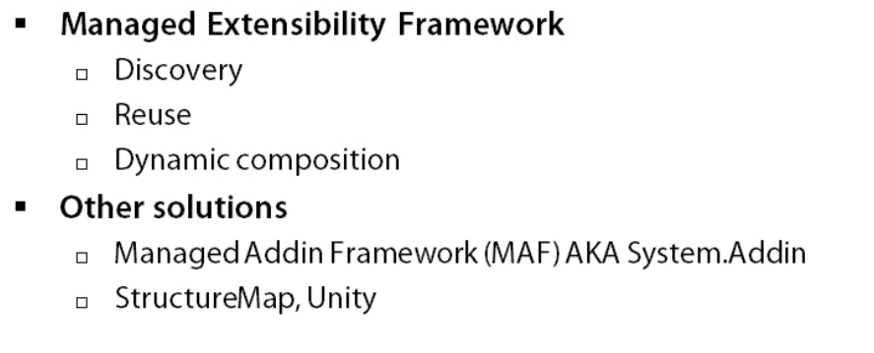

The other solutions above were not ideal due to its heavyweight and required too much effort on the developer’s part.

MEF is an attempt by Microsoft to addess the pinpoints of existing solutions for building extensible applications. However, it is not intended to replace any of the existing solutions like StructureMap and Unity.

MEF Highlights

1. Standard Addin framework that is lightweight and it comes built in into the .NET.
2. Before MEF, developers who intended to create plugin based extensibility in their applications needed to create an infrastructure from scratch or had to compose the infrastructure from existing solutions.
3. MEF provides a powerful attribute programming modal out of the box that makes it easy to hit around running and provides a standard way for application to compose the extension points as well as comsume extensions.
4. Tooling, instead of tools for discovery, typed dependency resolution, dependency injection as well as the rich metadata system that can be used for querying and filtering of extensions.
5. MEF is already in .NET 4.0 in the system.ComponentModel.Composition namespace.

MEF solves the problem of extensibility. An extensible system is one that allows for adding or placing functionality without modification to that system. Extensibility starts with composition.

## Building Extensible Applications

Composition is combining of parts to form a whole. The example of car is the the best suitable for understanding this.

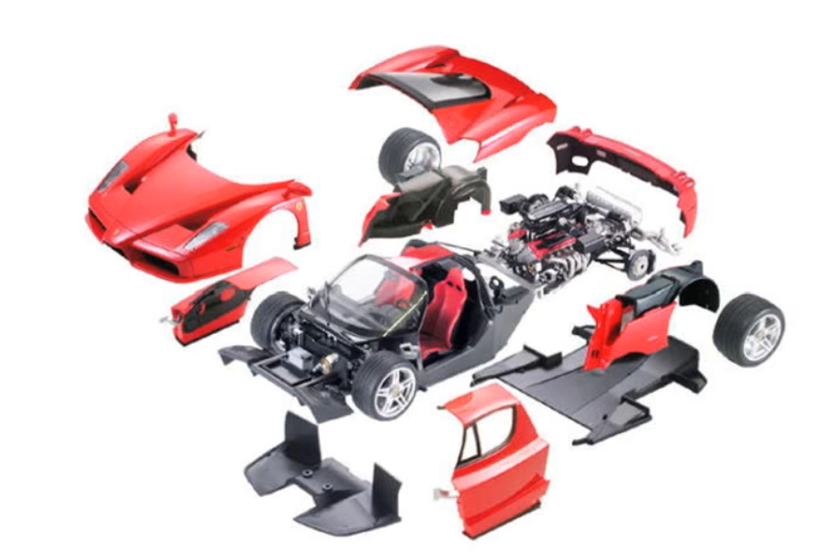

A car is a concept that encapsulates a set of subsystems that are wired up to work as a whole. The car you drive is just an instance that the factory created for you by composing all of the necessary parts like wheels, seats and the engine. Because of this, it is also extensible. Once we get the car home, we might not like the default wheels and can replace them in our car with fancy wheels using the provided extension point, the wheel hub.

Composable software systems are no different. They consist of decoupled, cohesive parts that expose what they provide and what they require. These parts get wired up to work as a whole. When done correctly, any one part can be substituted and the system won’t care as long as the substitute satisfies the expected interface.

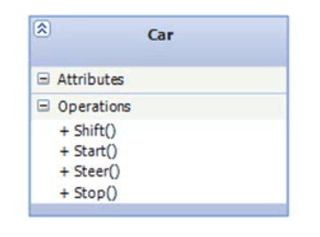

The above class operations are functions provided by purpose-built subsystems. The car itself is just a controller that consumes these subsystems and orchestrates their use. This class isn’t composable and extendable. Replacing the engine functionality will require modification to the class.

So, let’s decompose this class into something more managed and accurate. We start by moving the related functionality to a separate class.

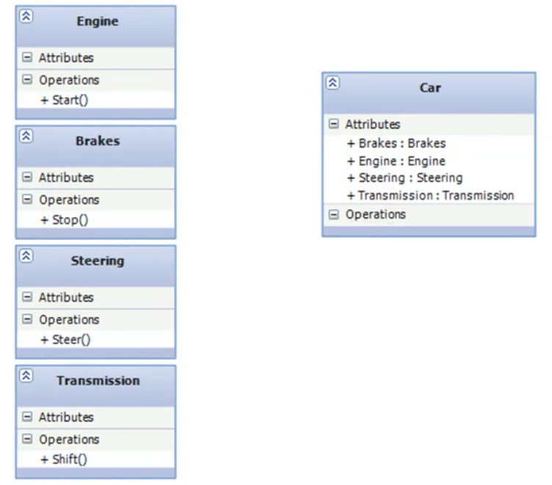

The car class is now built using composition and we have achieved a higher level of cohesion and separation of concerns. But the car still violates open-close principle and it still is inextensible. If we wanted to use different engine, we will still need to modify our car class directly. So, we need to focus on decoupling now.

Our car class needs to define what functionality it needs instead of defining a specific provider of that functionality.

In real life, the factory installs or injects specific parts into the car and our class should be the same way. We accomplish this with an abstraction. We know what type of functionality we need from each part type. So, we will extract that into interfaces and then work against those instead.

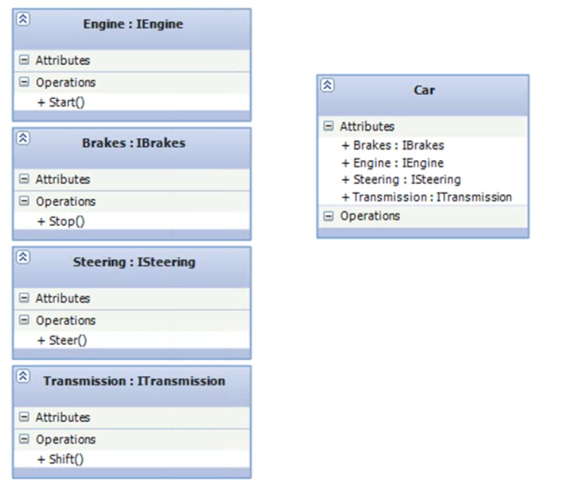

Now, our car can be composed from different parts and extended without modifying the original class. This example is pretty basic but it is enough to explain the concepts behind what we will be doing with MEF.

Building applications that are open for extension comes with a set of challenges.

1. How extension interface with the host application? This has to be done in a way that permits decoupling of the host and the component while avoiding any hard dependencies. This is usually achieved using contract assemblies and some type of reflection based framework. there are plenty of solutions that can achieve this and MEF is one of them. But MEF is lightweight and provides a simplistic programming modal that doesn’t get in the way.
2. Another challenge is discovery of components, which components are available and which of them should be loaded. A common approach to this is registration with configuration wither in XML or fluently in a bootstrapper. This method can quickly become a maintenance nightmare especially for larger applications or when components has specific requirements of their own. MEF avoids this approach by discovering unknown parts implicitly through composition which means that it’s flexible and doesn’t needs to be explicitly told what’s available.
3. Finally, there is communication between components. It usually solves those some form of an API but this approach is rigid and can potentially be limiting when encountering unexpected usage scenarios. MEF allows components not only to expose what services they provide but also which services they require. This makes communication between components possible, easy to do and flexible. Additionally, this model automatically makes extension available for extension.

## How MEF Works

MEF is based around parts. A part provides services to other parts, these are known as exports. Parts can also consume services by other parts, this is known as imports. Parts can pretty much mean anything. Meaning, they don’t have to be of a specific type nor do they have to implement specific interface. Parts can be internal or external, it’s all the same to MEF.

Containers are where the magic happens. Containers perform the composition of parts by matching up the importa with exports. Containers can make use of catalogues to learn about parts in which the container was not explicitly told about. Catalogues are aggregate containers that performs discovery of parts using various mechanisms depending on the type of catalogue being used. Foe example, a catalogue can scan a directory to find all assemblies and find all the parts in each assembly.

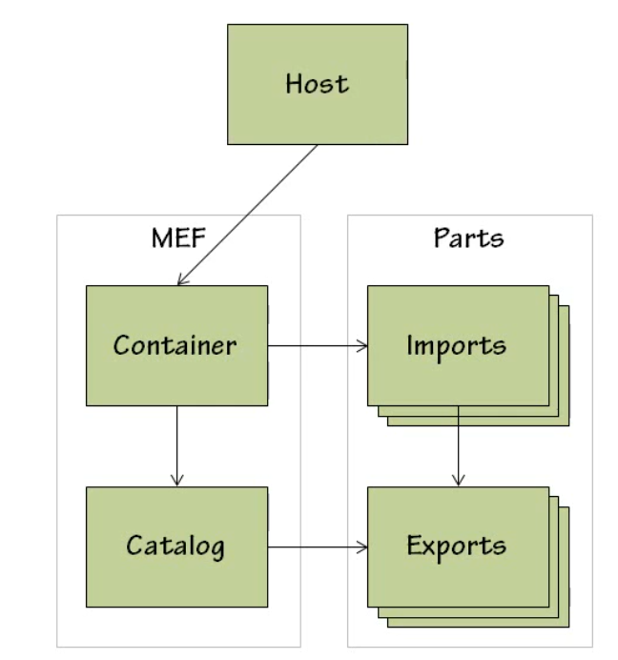

The host application uses the container to perform the composition of parts before it starts using them.

MEF matches exports and imports using contracts. A contract is an identifier used to indicate desired or provided capabilities. Exports use contracts to specify the services it provides, imports use contract to specify the services it needs.

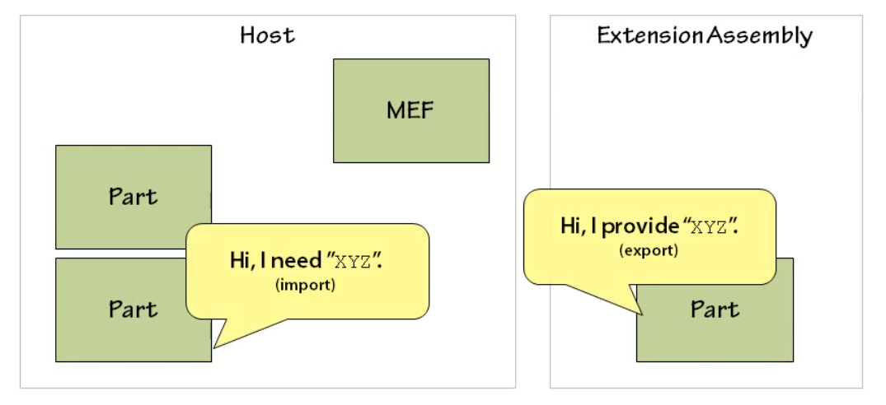

MEF then matches the import to the export based on the contract to satisfy the import.

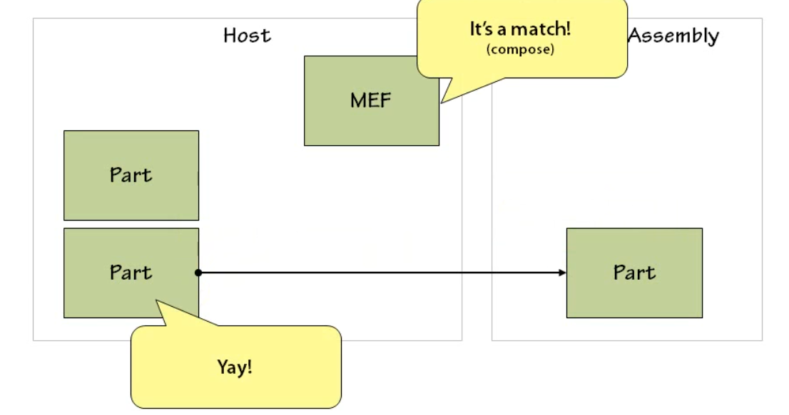

## Demo

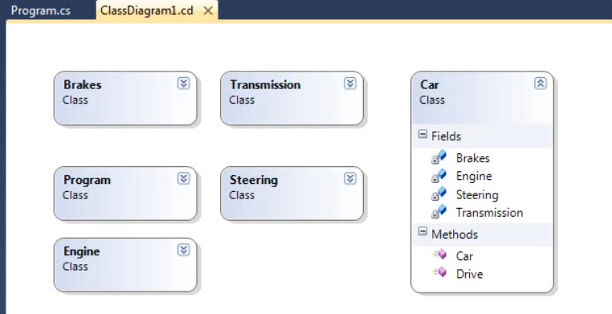

Our car class is a composite class containing properties for each one of the parts. It has a single method called drive that uses each one of those parts.

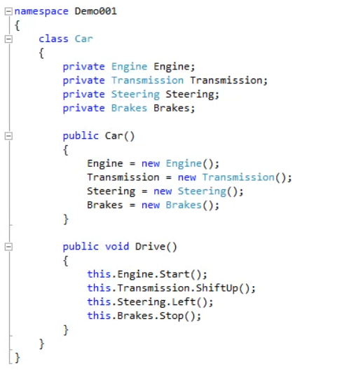

When we run it everything is good. But the car class is doing the work of setting up the part itself. By manually instantiating the types and the constructor, what we have is created hard dependencies of concrete types.

If we want to modify the car class later to use a different engine, we don’t have to edit the code directly.

So, let’s invert it by having MEF provide the part instances for us.

1. Add refernce to System.ComponentModal.Composition
2. Remove the constructor as we don’t need it anymore.
3. Now we will mark all of the car part classes as exports to make them discoverable.

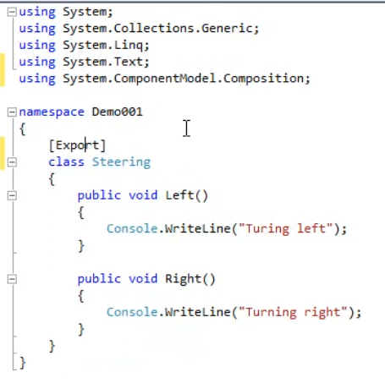

1. Back in the car class, we need to add the Import to all the properties so that MEF knows that it needs to satisfy these parts.

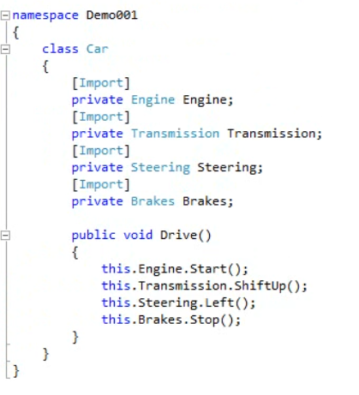

1. In the main method of our console application, we will set up a catalogue and it’s going to discover all of our exports. Then we will set the container and pass in the catalogue so that it can get a list of all the available parts that the catalogue discovered.
2. Then we will ask the container to compose the instance of our car class and then wee will call the drive method on it.

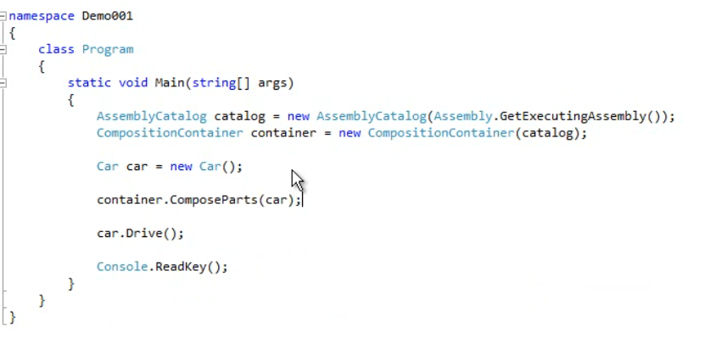

1. The car class is no longer responsible for instantiating its own dependencies and we are a lot closer in making it extensible.

## MEF v/s IOC

It might seem like MEF has a lot of overlapping functionalities with other available solutions, some of which are very mature. MEF does share some aspect of dependency injection container and just happens to be that it also uses IoC principles to accomplish its goals.

MEF is an implementation of IOC and is similar to dependency injection. However, there are some differences.

|  |  |
| --- | --- |
| **MEF** | **IOC** |
| Focuses on Extensibility and Discovery | Focuses on decoupling and testing in static systems. |
| Can discover components and dependencies without any prior knowledge. | Uses centralized, explicit registration. |
|  | Far more capable of doing their intended purpose than MEF |
|  |  |

MEF should be using conjunction with instead of a replacement for IOC framework.

IOC is about handling a set of known things

MEF is about handling a set of unknown things.

The Managed Add-In framework (MAF) is also a Microsoft solution in the extensibility problem space and is a true add on framework. Both MEF and MAF used to support a plug-in based architecture but they focus on different problem area.

MEF is about extensibility and discovery while MAF is about isolation and versioning. MAF provides isolation by allowing components to be loaded in a separate app domain or process and provides a communication channel between the host and the add-In. It also isolates developers form the complexities of such infrastructure. MAF is a heavyweight solution and is known being confusing.

You would use MAF if you need to ensure safety and stability of the host application by isolating add-ins, control the security context of the add-ins or need fine grain control over versioning.

MAF doesn’t handle any dependency resolution like MEF. If an add-in needs something the host will have to provide it. So, MAF doesn’t provide some of the flexibility that MEF does.

So, can MEF solve IOC problems? Yes, but MEF is not a general purpose IOC framework. MEF is an implementation of the IOC principle only as a means to an end. It is not a replacement for existing solutions. Infact MEF, MAF and IOC all solve different problems and can all be used in the same application together.

## Programming Modals

MEF itself was built to be extensible. The MEF didn’t want to lock developers to any single approach for part discovery. To accomplish this, the MEF architecture was separated into two major layers.

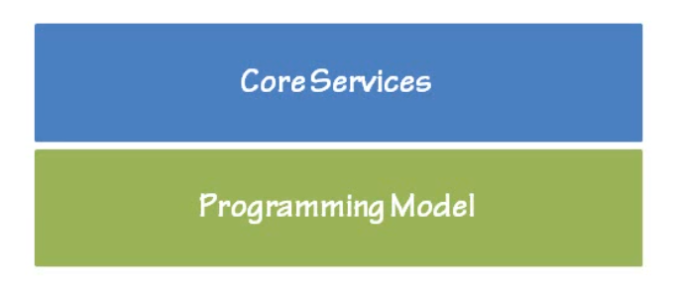

The core services layer contains all of the components MEF needs to do a composition and can be split up into two sublayers called hosting and primitives.

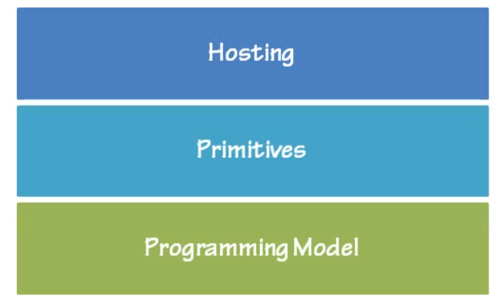

The hosting layer contains a composition engine and container and depends on the primitives layer to learn about parts that are available and their definitions.

The primitive layer is an abstraction layer that is meant to provide a way for MEF to remain loosely coupled from any discovery mechanism. What is meant here is that primitives provide and API for describing, creating and using components through a set of base types. Using Primitives, we can explain to MEF that a component exists and what services it provides known as exports and what services it needs known as imports.

The central type is a composable part which represents a live executing software component instance. A composable part will provide this capabilities to other component as exports and consume capabilities of other component through imports.

To provide MEF with the information about the services a composable part provides, we use the Export Definition which is a structure that holds contract and metadata details. A composable part will have one ExportDefinition for each service it provides.

On the flipside, we tell MEF about the services a Composable part needs using the ImportDefinition type which holds the specific details and constrain such as a contract name, metadata and card analogy, all details that will be used to match it to a specific export.

ComposablePartDefinition is a structure that describes what kinds of composable parts it can be created in a system and is used to create an instance of the part that it describes.

ComposablePartCatalogue groups the definitions together and provides a queryable interface for selecting appropriate definitions.

While primitives can be used directly , it isn’t recommended since it can be intensively and realy cumbersome. This is where the role of programming modal comes in.

A programming model is meant to simplify the process of interacting with the primitives layer and it is actually an implementation of the primitives layer. Programming modals are concerned with letting developers create ComposablePartDefinitions in a way that is optimal and closer relates to their domain specific goals.

Out of the box, MEF comes with an attributed programming modal which uses regular .NET attributes to map classes to composablePartDefinitions and other primitives.

It is possible to create your own programming modal. If you are not satisfied with the attributed programming modal, you can rather define parts in an XML file, then you can create your own simply by subclass in the various primitive types.

Custom programming models can be used in place of attributed programming modal or side-by-side, MEF doesn’t care.

# Attributed Programming Modal – Parts

## Exporting

It is the mechanism that a part uses to announce that it provides a service that other parts can use or take advantage of.

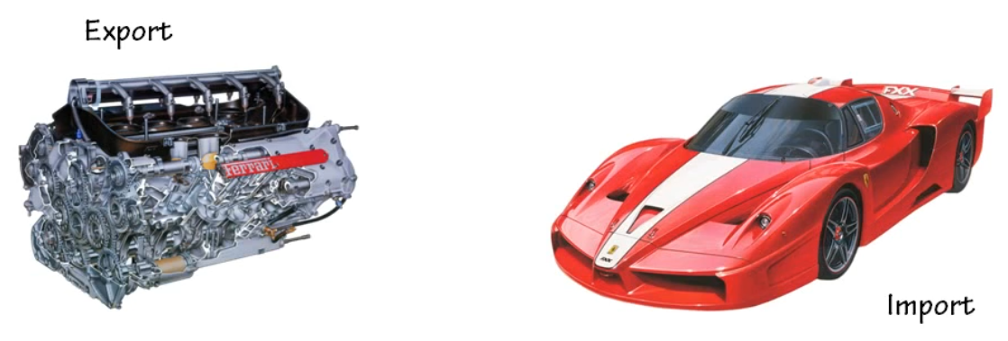

Engine is the part that a car will need to move. So, car will import the engine and the engine should be marked with Export.

Exports are declared by using the [Export] attribute on the class.

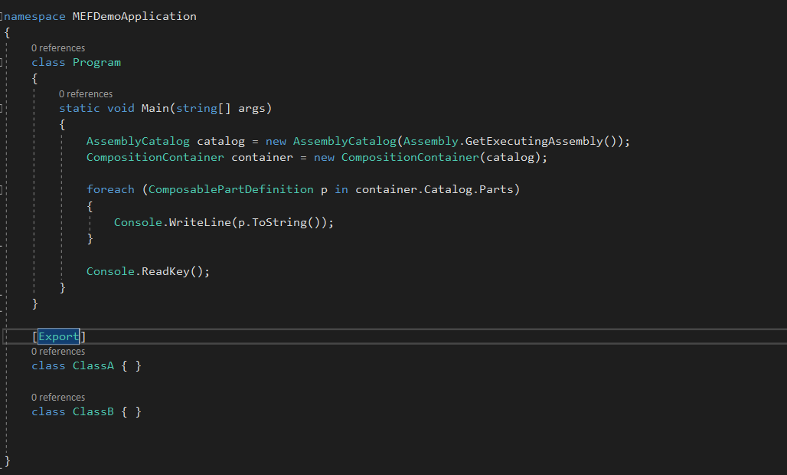

Since only classA is decorated with export, when we run this, we only see classA in the output window.

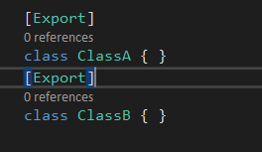

Now we will see both.

What if class B was a subclass of classA.

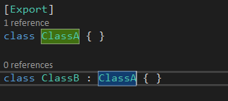

Now when we run this, we only see classA in the output. This is because when we export a class, it is only applied to that class and won’t be inherited. Any subclasses will also need to be explicitly exported.

What if we wanted to automatically imply subclasses as an export, or any subclass that implements a specific interface should be an export?

Using Export attribute won’t be enough. For this purpose we need to use InheritedExport Attribute.

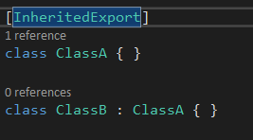

Now when we run this, we can see both the classes.

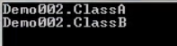

When an interface is attributed with an InheritedExport attribute, any class that implements the interface will be marked as an export.

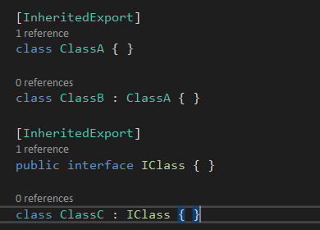

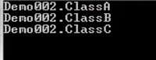

## Importing

It is the mechanism that apart uses to define the need for a service. The import attribute is used to specify the needs and is applied to type members. It is not applied to the type itself.

Exports and imports actually have 3 different cardinality.

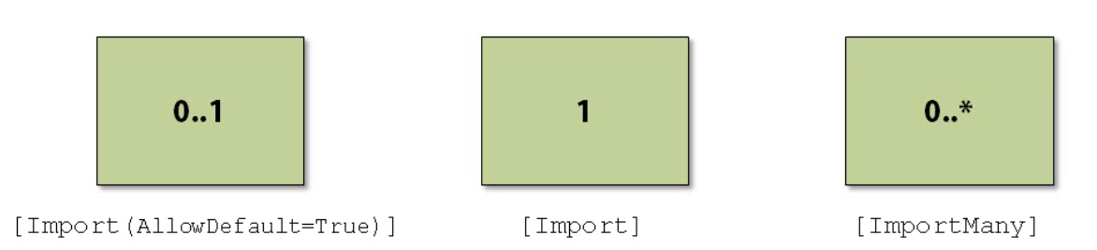

By default, the Import attribute has an exactly 1 cardinality. This means that it must have one and only one exports to match. If no exports are found or more than one is found, an exception will be thrown.

When an import can’t be matched to an export, an exception is thrown. The Import Attribute has an AllowDefault property which when set to true prevents the exception from occurring as it allows the members to be initialized with its default value if no exports are found. The default will be null for reference types, 0 for value types.

Setting the AllowDefault to true changes the cardinality from 1 to 0 or 1. So, it is okay if not export matches are found but an exception will still be thrown if two or more are found.

It’s common that we would want more than one of the same type of export. For example, if we have a photo editing application, we might desire the ability to bring in multiple plugins for image manipulation. Only allowing one plugin just wouldn’t be good business.

*Now, you would be half right if you guess that setting the property to a collection would allow us to import multiple plugins, but doing so will cause MEF to still only import a single Export, but it would then look for a part that was a collection type, not really what we want.*

Remember, the ImportMember cardinality is exactly one. So, we need to change over to ImportMany Attribute. The ImportMany attribute works exactly like the Import attribute, except that the cardinality is 0 or more no matter what and it can only decorate a member that represents a collection.

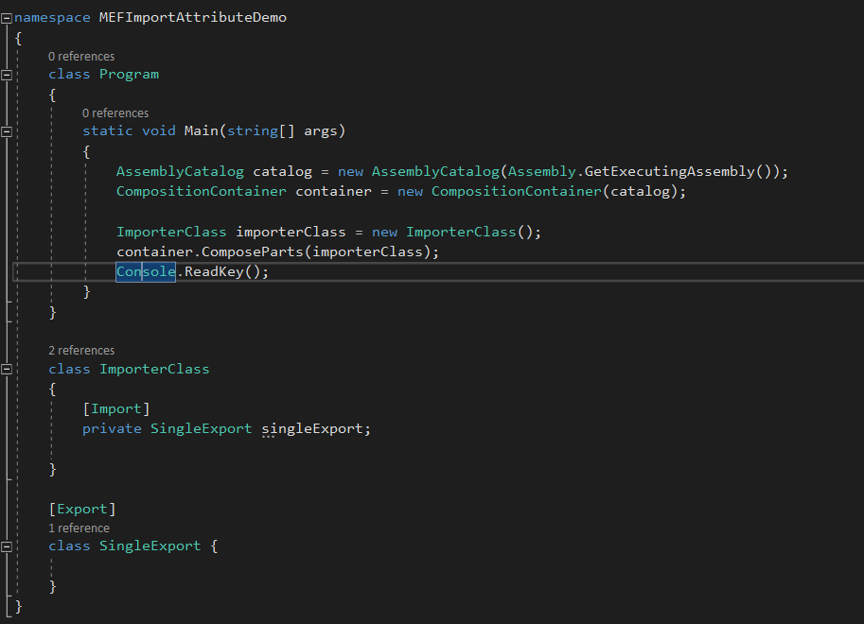

When we run this we get no error as only one export is matched with the importerClass.

But when we comment the Export Attribute and run the application, it throws an exception

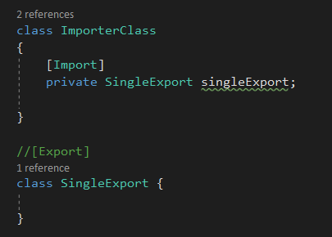

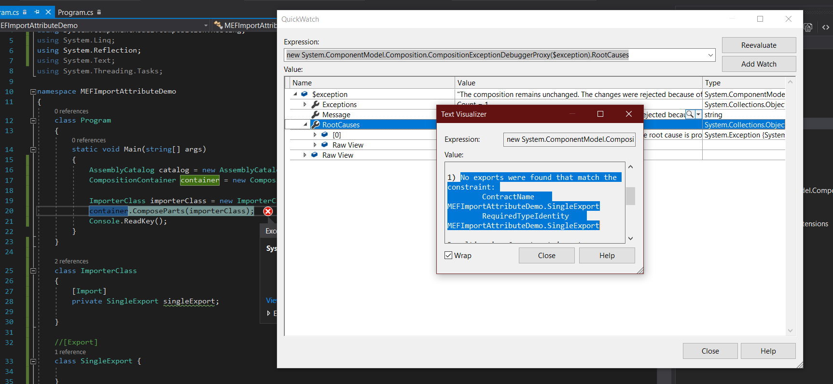

The exception says that no exports were found that satisfies the import.

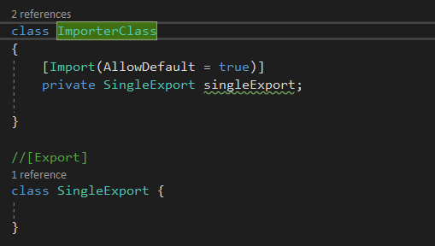

Setting the AllowDefault Property of Import Attribute prevents the 0 exports matched exception.

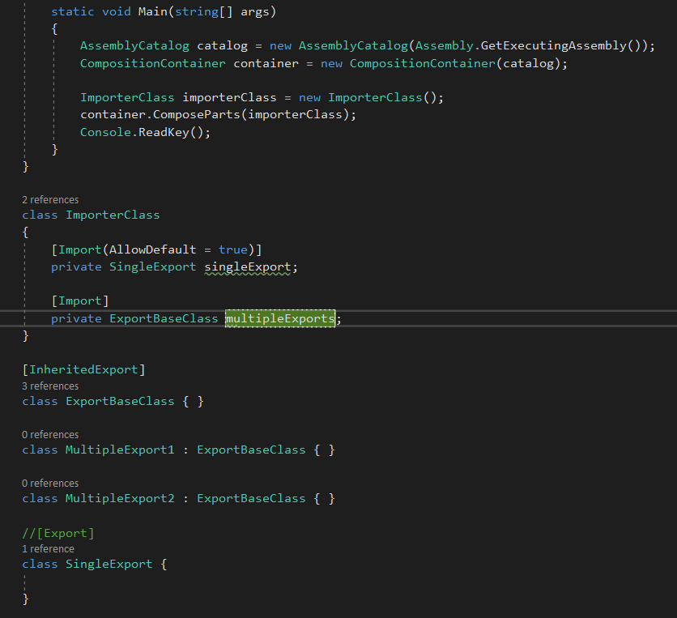

Now that we have multiple classes that inherits from the exportBaseClass, so those classes are also gets Export because of the InheritedExport Attribute. So, our multipleExports type member although decorated with an Import Attribute will get matched with multiple exports and will throw an exception because Import Attribute cardinality is 1.

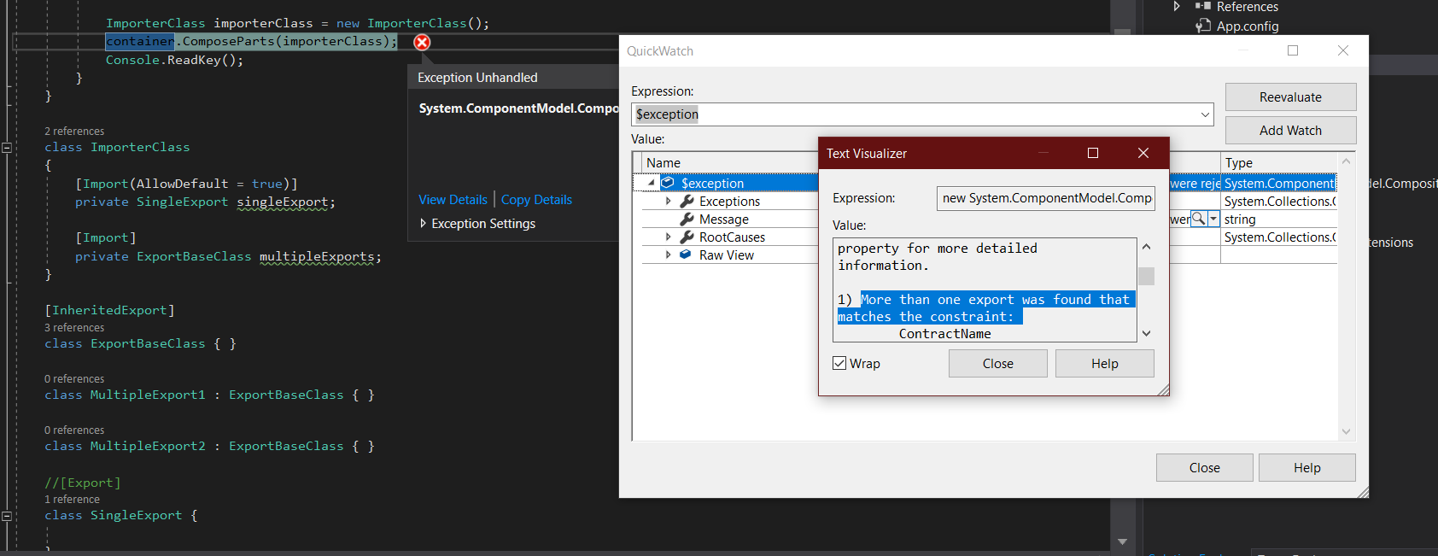

To resolve this, we need to decorate out multipleExports type member with ImportMany Attribute instead of Import Attribute. But ImportMany can only be applied to a collection so wee need to change the type of our type member from

[Import]

private ExportBaseClass multipleExports;

to

[ImportMany]

private IEnumerable<ExportBaseClass> multipleExports;

## Contracts

In order for exports to be matched with imports, there needs to be some piece of information that can be used to determine a match. That piece of information is referred to as contract.

Contracts are fairly straightforward consisting of only two parts – a type and a string. When using the export or import attribute, we have the options to specify two elements that make up the contract. Contract name which is a string and contract type which is a type.

We can provide one, none or both.

If we don’t specify the values, MEF will infer them for us.

The end result is a string that is made up of the contract type and contract name. if no contract type is defined, the type is inferred from the class or type member that the attribute is decorated with.

It’s okay if you don’t want to specify a contract type, but because it will be inferred, you should be aware that not being explicit could have unintended side effects as well.

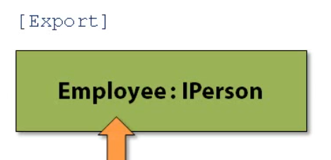

If we decorate an employee class that inherits from IPerson, the contract type inferred will be of type Employee. If we are expecting an import expecting a type of IPerson, a match wont be made.

Let’s create a WinForm App with the purpose of allowing plugins to be added that will modify a text label. The form has a menu strip that we will be adding menu items to.

We define plugin using an interface IMenuPlugin

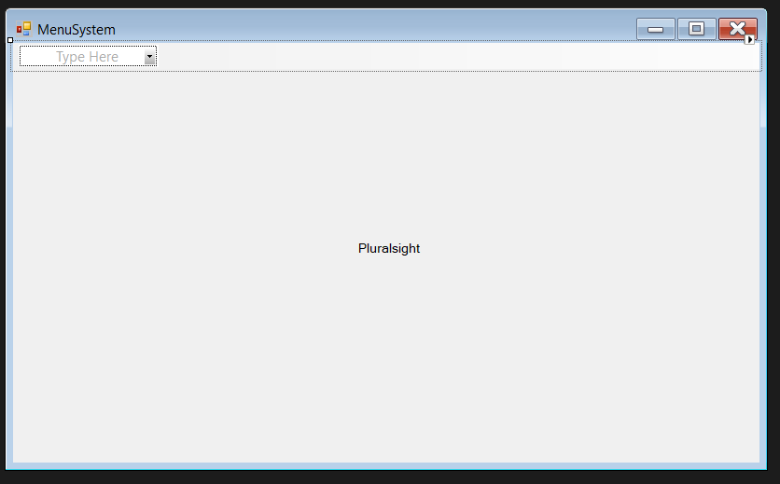

Windows form design containing a Menustrip and a label text

namespace MEFContractsDemo

{

public partial class MenuSystem : Form

{

[ImportMany]

private IEnumerable<IMenuPlugin> sizePlugins;

[ImportMany]

private IEnumerable<IMenuPlugin> colorPlugins;

public MenuSystem()

{

InitializeComponent();

}

private void MenuSystem_Load(object sender, EventArgs e)

{

InitializeMenus();

}

private void InitializeMenus()

{

var sizeMenu = new ToolStripMenuItem("Size");

var colorMenu = new ToolStripMenuItem("Color");

foreach (var p in sizePlugins)

{

sizeMenu.DropDownItems.Add(BuildMenuItem(p));

}

foreach (var p in colorPlugins)

{

colorMenu.DropDownItems.Add(BuildMenuItem(p));

}

menuStrip1.Items.Add(sizeMenu);

menuStrip1.Items.Add(colorMenu);

}

private ToolStripMenuItem BuildMenuItem(IMenuPlugin itemDefinition)

{

ToolStripMenuItem menuItem = new ToolStripMenuItem();

menuItem.Text = itemDefinition.MenuText;

menuItem.Click += new EventHandler(menuItem_Click);

menuItem.Tag = itemDefinition;

return menuItem;

}

private void menuItem_Click(object sender, EventArgs e)

{

IMenuPlugin plugin = ((ToolStripMenuItem)sender).Tag as IMenuPlugin;

plugin.ChangeLabel(this.lblMainMessage);

}

}

}

Creating a Size and Color Menu Item by using our IMenuPlugin interface

namespace MEFContractsDemo

{

interface IMenuPlugin

{

string MenuText { get; }

void ChangeLabel(Label label);

}

}

The Plugin.cs file below has 4 classes that are exported with 2 for each menuItem Size and color.

namespace MEFContractsDemo

{

[Export]

class SizeUpPlugins : IMenuPlugin

{

public string MenuText { get { return "Size +10"; } }

public void ChangeLabel(Label label)

{

label.Font = new System.Drawing.Font(label.Font.FontFamily, label.Font.Size + 10.0f);

}

}

[Export]

class SizeDownPlugins : IMenuPlugin

{

public string MenuText { get { return "Size -10"; } }

public void ChangeLabel(Label label)

{

label.Font = new System.Drawing.Font(label.Font.FontFamily, label.Font.Size - 10.0f);

}

}

[Export]

class ColorRedPlugin : IMenuPlugin

{

public string MenuText

{

get { return "Red"; }

}

public void ChangeLabel(System.Windows.Forms.Label label)

{

label.ForeColor = Color.Red;

}

}

[Export]

class ColorBluePlugin : IMenuPlugin

{

public string MenuText

{

get { return "Blue"; }

}

public void ChangeLabel(System.Windows.Forms.Label label)

{

label.ForeColor = Color.Blue;

}

}

}

Finally we initialize the MEF in our program.cs

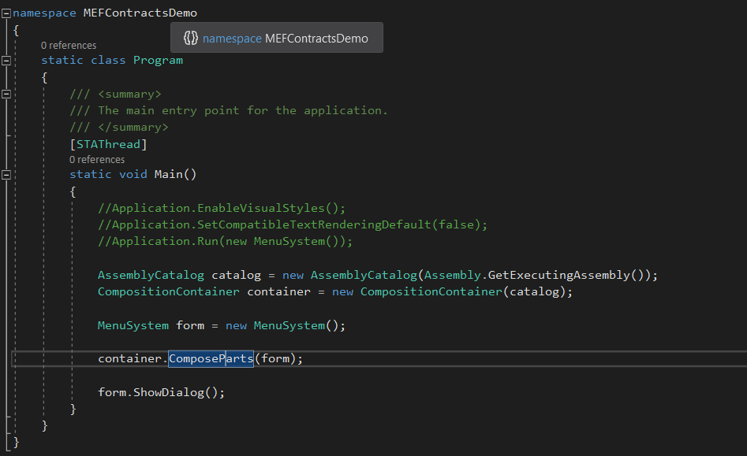

When we run the project, we see that the Menu Item does not show anything.

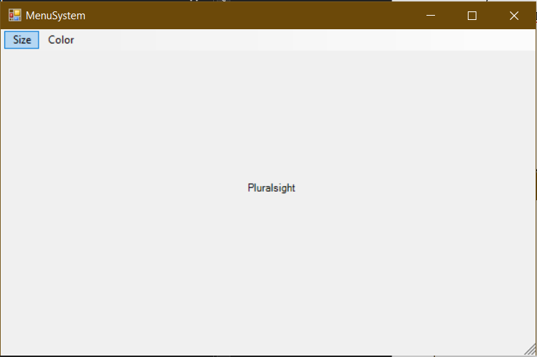

This is because the plugins are being exported as a concrete types meaning that the type that they are exported with is their class name and not IMenuPlugin.

If you see the code above, you will notice that the Import expects the type to be IMenuPlugin. And this happened as MEF inferred the contract details for us as we have not explicity told it the type.

So, we need to explicity define the type of contract being exported in the plugin.cs class like below.

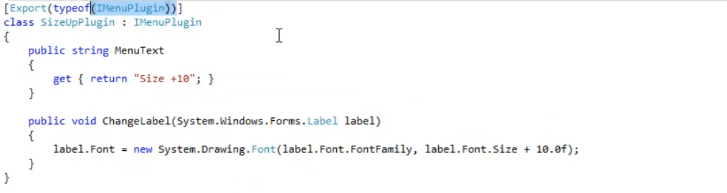

By doing this, we can see that the types are matched and menus are now shown

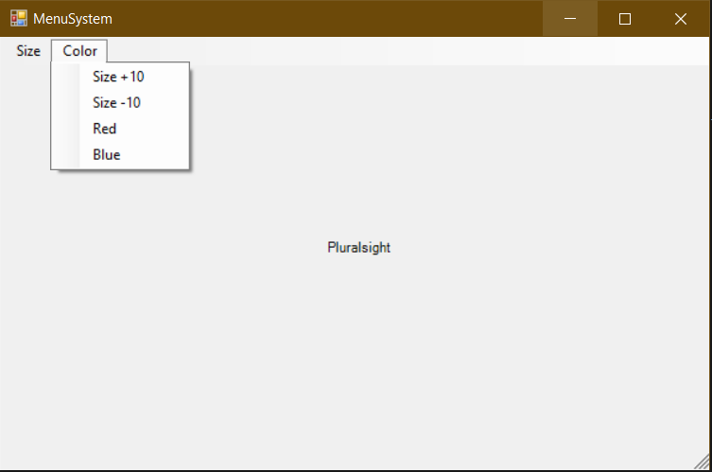

But here we can see all four plugins in both menu. This happened because export uses IMenuPlugin. We need to fix this. We can fix this by using 2 different interfaces, one for color and one for size, but that isn’t an ideal solution since we need to add and maintain new interfaces when we wanted to add new plugin.

Instead We can also fix this by providing the contract name like below. We have to do this on both the exports and imports. Providing a contract name in the imports says to import a specific subset of export.

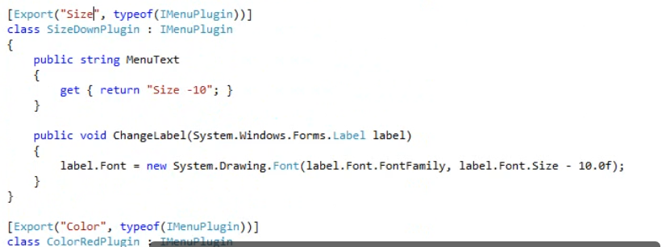

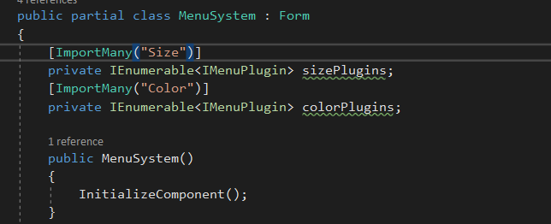

This fixes our problem in a very simple way.

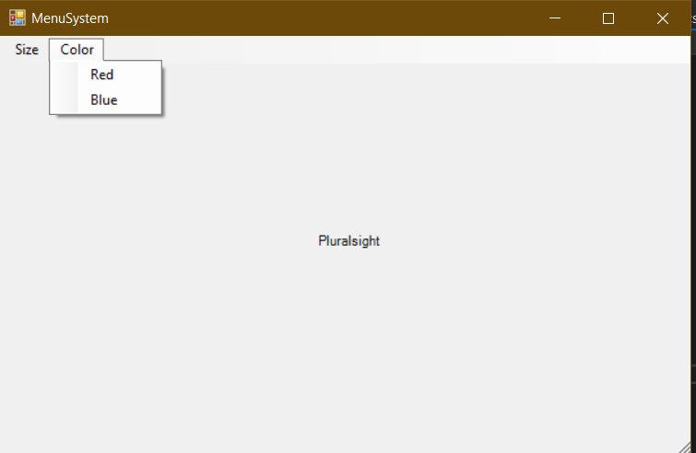

### Best Practices when working with contracts

1. Use an interface for a contract type instead of concrete type when exporting classes. Using concrete type will limit the flexibility. Using an interface allows the decision about which concrete type is used to be made by the extensions. Using an interface will make it easier to use ImportMany attribute.
2. Since contracts name is just a string, its susceptible to spelling and typing errors. Define string constants for contract name to avoid this.
3. It is always a good idea to define the contract interfaces and name constants in their own assembly. Using a contract assembly will make it easier for extension builders to build their extensions for your application since you can easily distribute the assembly to extension builders for them to consume.

## Metadata

There are situation when we need to provide extra information about an export. MEF does this with Metadata which is essentially a set of key value pairs that we can imply to an export to be used for querying and filtering.

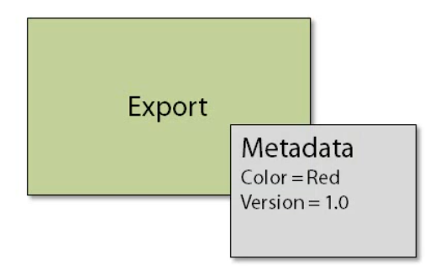

The best part of metadata that it can be discovered and used before the parts are created, which means we can avoid loading up plugins if we don’t need them. MEF supports both weakly and strongly typed metadata.

To provide metadata on an export, we use the provided EXportMetadata Attribute which takes in a name and a value. We ca apply multiple metadata values using this attribute. ExportMetadata Attribute is a mechanism we use to provide weakly typed metadata for an export.

In order to use the metadata provided by an export, we need to make use of new generic type, Lazy T.

Lazy<T> provides support for lazy initialization. Actually we need to use a variant of Lazy T, Which is Lazt<T,Metadata>. It provides a lazy indirect reference to an object and its associated metadata. This type has three properties that we care about.

1. Value: which holds the reference to the object in which loading is being deferred.
2. IsValueCreated: this indicates if the value is created or not.
3. Metadata: this is how we access metadata provided by the export.

----------------------------

Our winform plugin app in contracts works by using collections and relying on the importMany attribute to populate them.

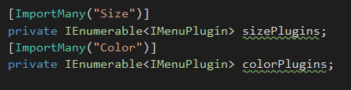

The problem with this approach is that all of the plugins are loaded in the memory at once even if we don’t use them. Do we need them to be loaded if we aren’t using them? Technically we are using them, for getting the menu text from the interface. If we don’t load the plugin, how do we get the menu text. This is where metadata comes in.

We can use metadata to provide the app with menu text without loading the plugin.

This is how we change out plugin interface and class.

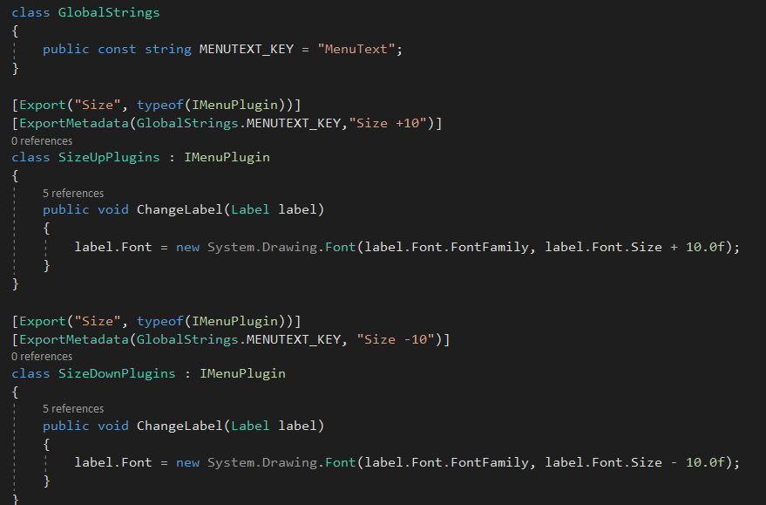

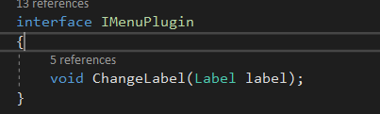

Now we need to lazy load the plugins when importing.

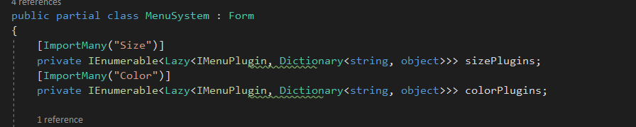

Once we do this, we will break our menu loader. Instead of taking the interface, we will take the lazy type interface.

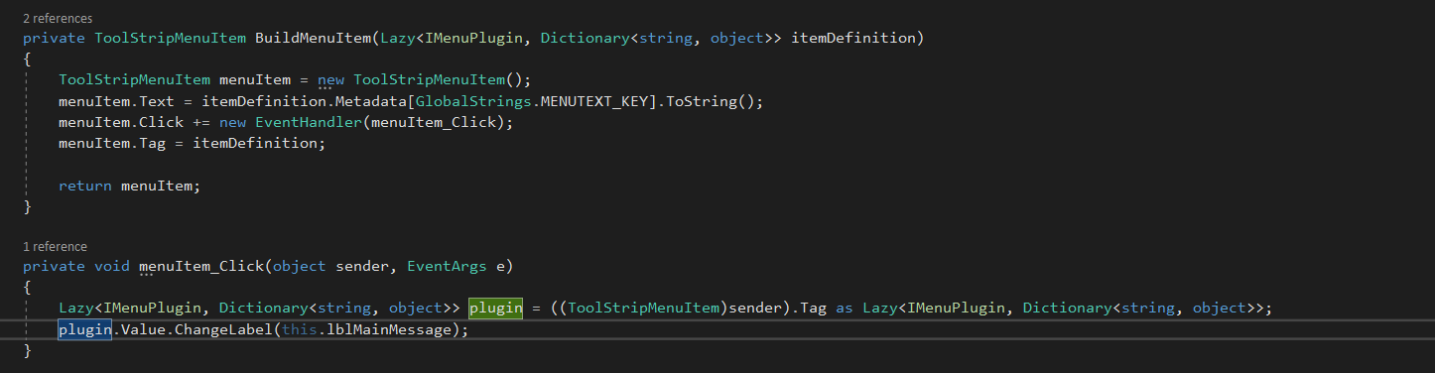

Now when we run this solution, we can see that our menus are working fine and are shown. As soon as we click on the menu item, We get our breakpoint it in the click section

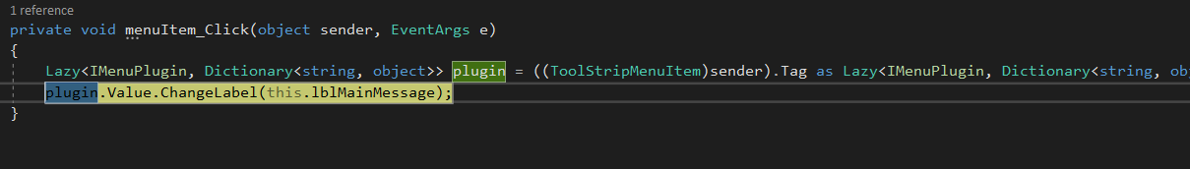

And if we quick watch our plugin variable, we can see that the value of IsValueCreated is false. This means that the plugin is not yet loaded.

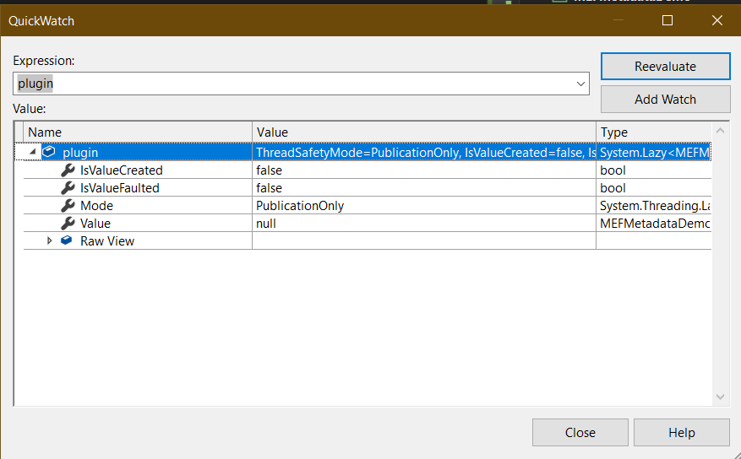

When we hit F10 and execute the line

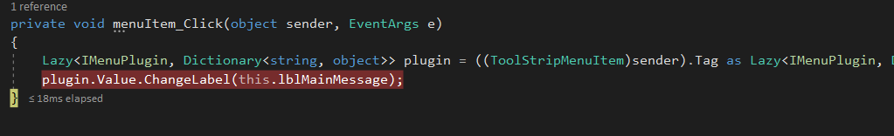

Now we can see that the value of IsValueCreated is set to true and the plugin is loaded.

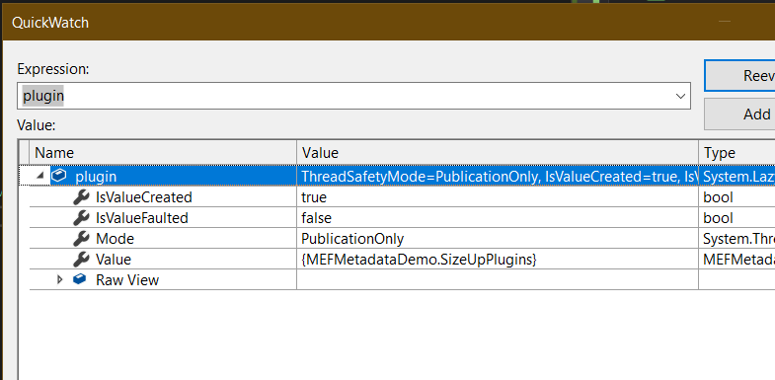

The problem with the ExportMetadata Attribute approach is that it isn’t strongly typed and it isn’t type check at compile time. And there is no gurantee that the requested metadata key exists.

To solve these issues we can use strongly typed metadata. There are two pieces required to do so.

1. A custom attribute
2. An Interface

--------------------------------------------------------------------------------------------------------------------------

So, let’s now start off with changing from weakly typed to strongly typed.

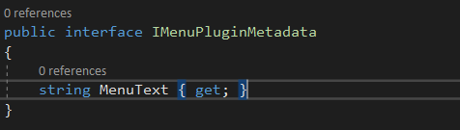

For interfaces that will be used for metadata, they aren’t allow to have public setters, so we need to remove it from the definition.

Next we need to create a custom attribute. We will create a class and inherit it from Attribute base class. Also we will implement out Metadata Interface. The key to this attribute id that we need to decorate our class with [MetadataAttribute] which tells MEF that out attribute will provide metadata for a typed marked as an export.

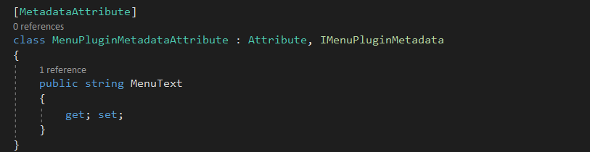

Now we need to update our code. We need to change the dictionary to our Metadata interface.

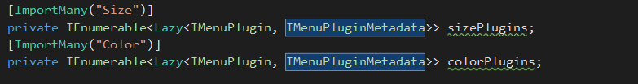

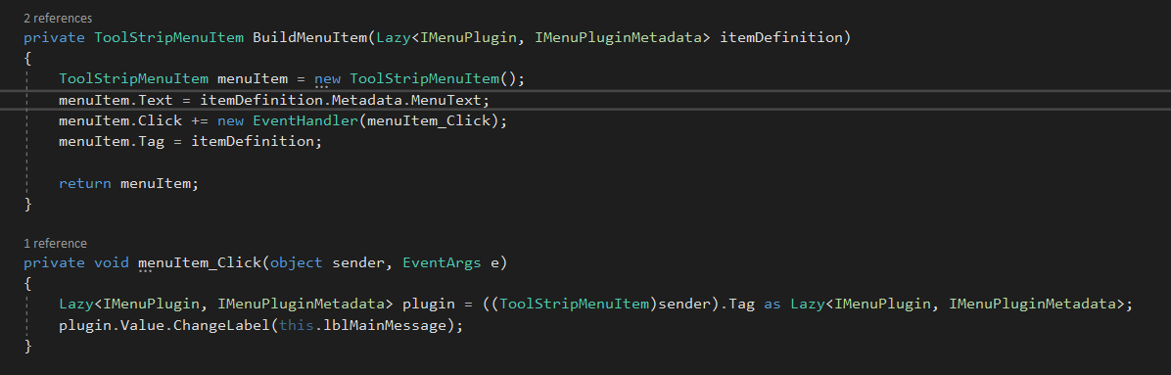

Finally, we need to use our Attribute in our plugin

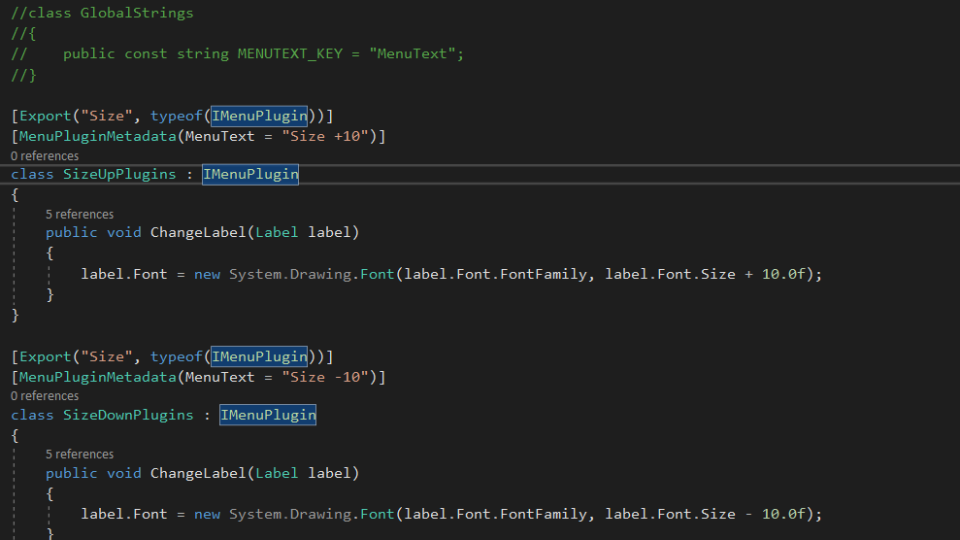

Notice that we have removed ExportMetadata Attribute and also removed GlobalStrings Class which we were using for MenuText Key.

It still works the same way. Unless we click on the menu item, no plugins are loaded. Once we click the menu item then only the respective plugin is loaded. This is same as before but just with strongly typed metadata.

But there is still one issue. An export can skip the setting of menu text. And the menu text will be blank for the skipped one as shown below. This could cause an exception.

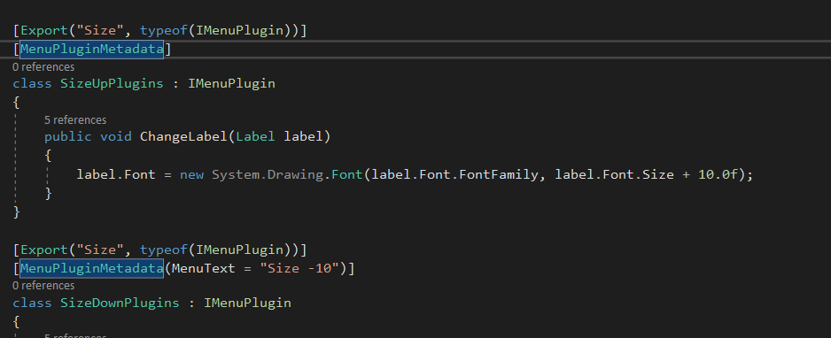

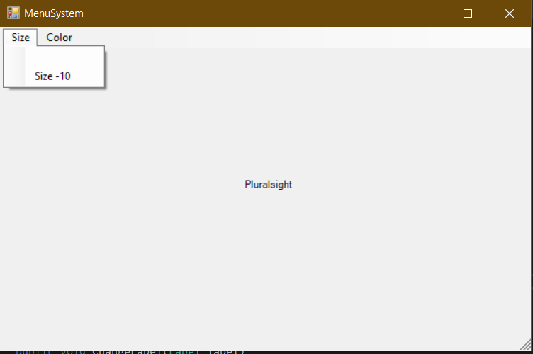

One of the benefits of using strongly typed metadata is that we can guarantee that a value is set by making the property set private and using a constructor to take in the value and set it that way.

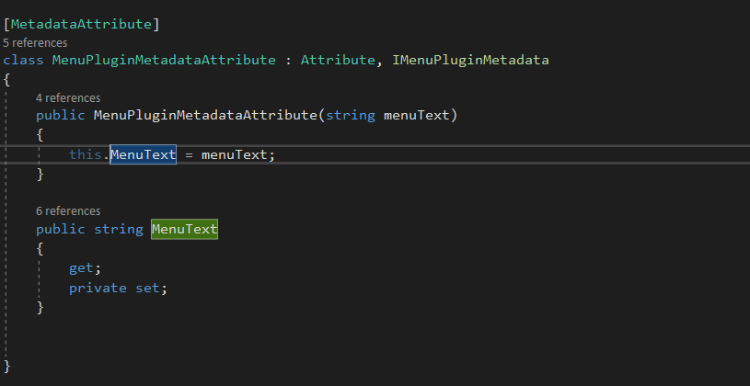

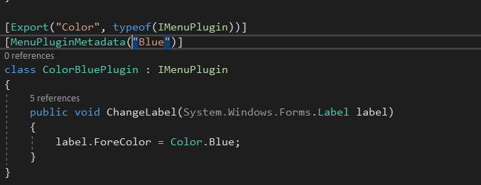

This way it can never happen that a value for the menutext is not provided as it will throw compile time error for the missing value.

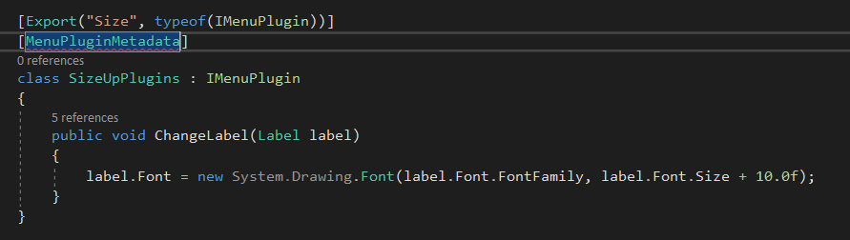

See the red line above, it is there indicating the missing value.

## Exporting and Importing Methods and Properties

In addition to exporting and importing entire types, we can also define exports and imports on a more granular level i.e. methods, properties and fields. It has an advantage of importing values and actions without needing to know anything about the type from which they originate. And you can also export sealed types, like seal our types or types from a third party, which we generally don’t have access needed to apply an export attribute directly.

To export and imports methods, properties and fields, we only need to apply the import or the export attribute the same way we have been doing with the types.

Let’s start by building a plugable integer calculator.

1. We will have a calculator class that will be exported having a calculated method which takes in a string and returns an integer. This method will parse out the input that is passed to it, then perform the calculation and return the result.
2. The HeperMethod class will do the parsingwith the help of Parse method which returns an object of CalculationModel class and is also exported as contract name Calculation parser.
3. The Calculator class has a parseCalculation field of the Func type that serves as an import for the CalculationnParser export. We actually don’t know what method will be supplied and where its coming from but we know that we want that method with a specific signature, one that takes a string and returns CalculationModel class object. So we are using a generic function type to define that for us.
4. Once we get the parseCalculation field, we can use it in our calculate method. But now we need to know how to calculate the input based on the operation that the user specified.

We could use a switch statement and just check for an operator like +, - etc. But let’s just say we have the support for only +, -, * and /. if we later wanted to support the module operator(%), we would have to come back in and modify the switch statement.

Instead lets import a set of methods that would do the calculation and we can just figure out which one to call based on the metadata.

1. To do this, we just need to add an IEnumerable of Lazy Func. The Func is defined as taking in two integers and returning an integer. Then we will supply a Dictionary for the metadata structure.

[ImportMany]

private IEnumerable<Lazy<Func<int, int, int>, Dictionary<string, object>>> computationMethods;

1. Back in the Calculate Method, we can query the collection and find the right method call based on the operator.
2. Then we get the result by invoking the method and finally return the result.
3. Now all we need is a set of methods that will do the calculation ad export those methods.

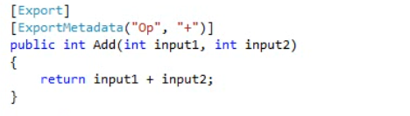

-----------------------------------------------------------------------------------------

class Program

{

static void Main(string[] args)

{

AssemblyCatalog catalog = new AssemblyCatalog(Assembly.GetExecutingAssembly());

CompositionContainer container = new CompositionContainer(catalog);

var calculator = container.GetExportedValue<Calculator>();

while (true)

{

Console.Write("Enter calculation: ");

string input = Console.ReadLine();

Console.WriteLine("Result {0} ", calculator.Calculate(input));

}

}

}

[Export]

class Calculator

{

[ImportMany]

IEnumerable<Lazy<Func<int, int, int>, Dictionary<string, object>>> computationMethods;

[Import("CalculationParser")]

Func<string, CalculationModal> parseCalculation;

public int Calculate(string input)

{

int result = 0;

var calculation = parseCalculation(input);

try

{

var actionToRun = computationMethods.First(c => c.Metadata["Op"].ToString().Equals(calculation.Operation));

result = actionToRun.Value(calculation.Input1, calculation.Input2);

}

catch {

}

return result;

}

}

-----------------------------------------------------------------------------------------

[Export("CalculationParser")]

class HelperMethod

{

[Export("CalculationParser")]

public CalculationModal Parse(string input)

{

Regex regex = new Regex(@"(\d+)(.)(\d+)");

Match match = regex.Match(input);

CalculationModal calculation = new CalculationModal()

{

Input1 = int.Parse(match.Groups[1].Value),

Input2 = int.Parse(match.Groups[3].Value),

Operation = match.Groups[2].Value

};

return calculation;

}

}

-----------------------------------------------------------------------------------------

class CalculatorOperations

{

[Export]

[ExportMetadata("Op", "+")]

public int Add(int input1, int input2)

{

return input1 + input2;

}

[Export]

[ExportMetadata("Op", "-")]

public int Subtract(int input1, int input2)

{

return input1 - input2;

}

[Export]

[ExportMetadata("Op", "*")]

public int Multiply(int input1, int input2)

{

return input1 * input2;

}

[Export]

[ExportMetadata("Op", "/")]

public int Divide(int input1, int input2)

{

return input1 / input2;

}

}

-----------------------------------------------------------------------------------------

public class CalculationModal

{

public int Input1 { get; internal set; }

public int Input2 { get; internal set; }

public string Operation { get; internal set; }

}

-----------------------------------------------------------------------------------------

Here also, for supporting other operators, we have to come and edit the code but just need to create a method and export it with the operator metadata. So in order to extend the functionality with other operators we don’t even need to touch the Calculator class.

NOTE: it is important to note here that we are not using any reference to CalculatorOperation class to work with the methods. We don’t know and we don’t need to know and that’s one of the benefits of exporting methods and properties.

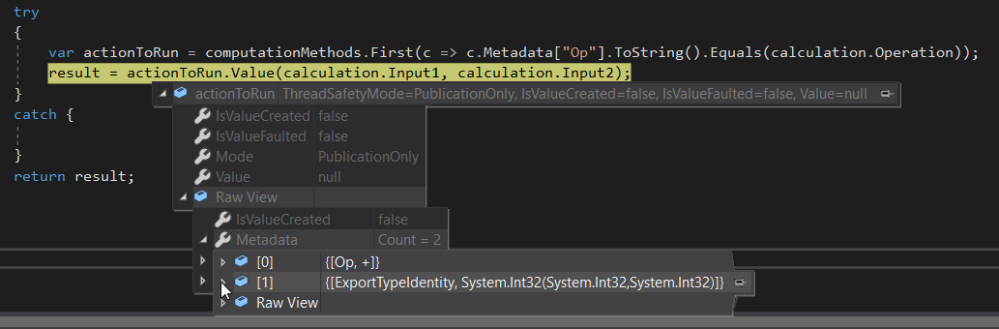

Notice here that the conmputationMethods property takes in a Func (Which takes in 2 int and output and int) and a Dictionary of Metadata structure.

When 2+2 is passed as string, the parser breaks it down to Input1 = 2, Input2 = 2 and Operator = +.

Also notice that the IsValueCreated is false till now. This means that the plugin is not created yet and will be created once the method is called. The metadata Structure signifies that it will search for a method which is exporting Metadata with Operator + and return an object of signature what takes in 2 int and output an int. the add method will be returned and the two passed input will be added.

## Constructor Injection

Up to this point we have been using MEF in a property conjunction fashion, but MEF gives us a way to resolve the dependencies using a constructor engine style. We do this using the Importing Constructor Attribute. this attribute can be applied to a constructor of a class that takes in all of the dependencies that is needed to be imported as parameters. MEF will see the attribute and will try to resolve each parameter just as if we had applied an import attribute.

In our Winforms app, as it sits we are initializing the Menu on the forms Load method.

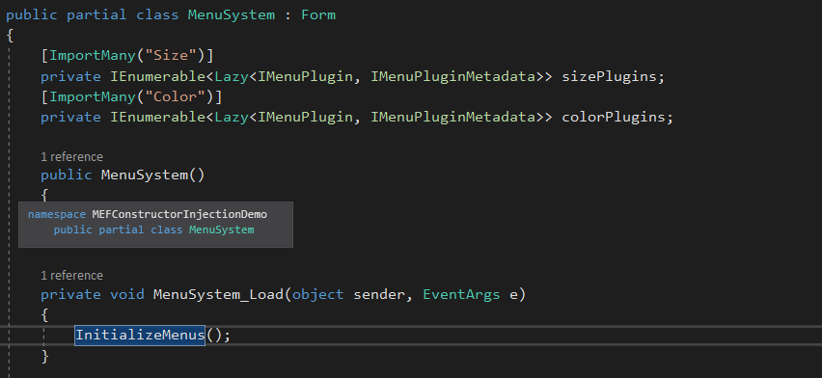

If we wanted the menu items to be loaded after the form is initialized the rest of the components, we will move the call to the Initialize Menu to the bottom of the constructor.

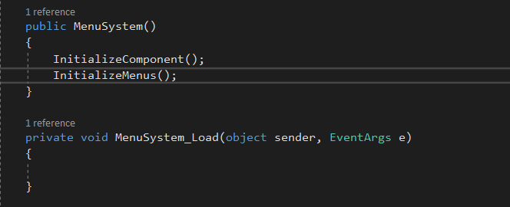

But now when we run, we get an exception. MEF doesn’t initialize our plugin collections until after the constructor finishes, which means our part is in an unstable state until then.

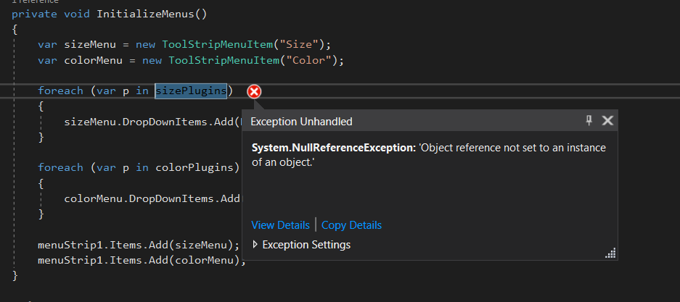

So what we do is decorate the constructor with importingConstructor attribute and then we basically make our imports, constructor parameters. And just because we make them parameters, we still have to make sure that we apply the appropriate decorations to make sure MEF satisfies them correctly. So,we will also apply the ImportMany attribute to the constructor parameters. If we didn’t MEF will try to import a single part with a Contract of IEnumerable Lazy which wouldn’t work since we don’t have any of those.

Also to mention, we still need to tell MEF about the contract name.

Since we have changed the constructor for MEF to satisfy the imports, we can’t just new it up anymore. So what we will do is apply an export to the form so that it gets picked up by the catalogue and added to the container.

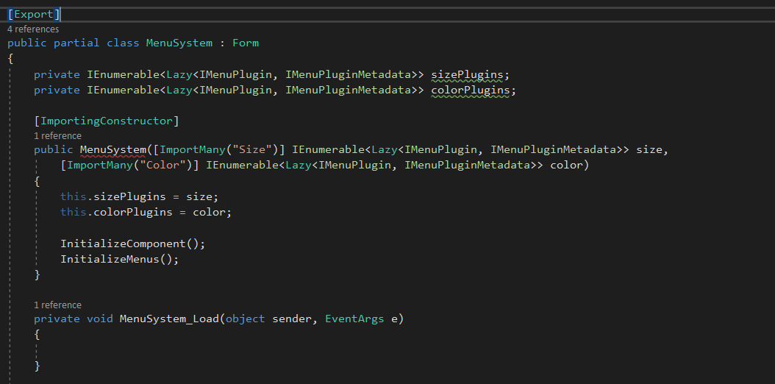

Change the way we are getting MenuSystem from new MenuSystem() to container.GetExportedValue

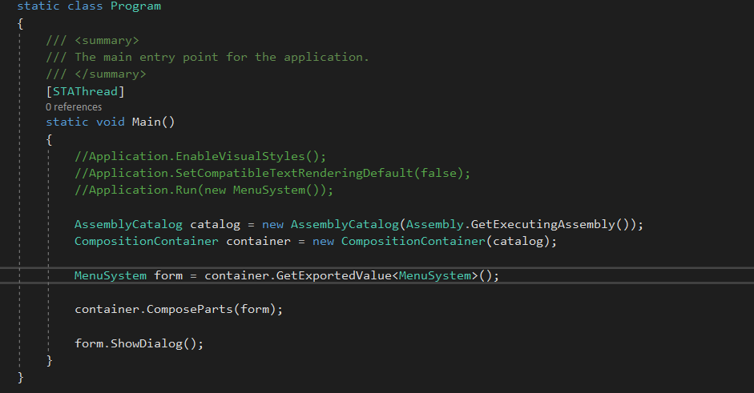

Now when we run, we get an exception. This is because, we switched to Constructor Injection on a class that is public. Our constructor parameter types have to have an accessibility that is compatible with the class. **This is something to keep in mind.**

So, let’s update our plugin interface so that it matches the class.

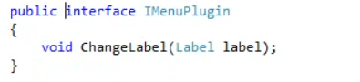

Everything works same as before but the plugins and menus are setup and ready to use when the form is instantiated instead of being setup in the forms load event handler.

# Attributed Programming Model – Composition

The composition container is where the magic happens. I keeps track of which parts are available, what their dependencies are and manages the composition of those parts.

It also allows us to retrieve and query for fully composed instances of our parts.

Going back to our car analogy, the composition container would be the factory where all of the parts are gathered then wired up in the correct order to produce a car that’s fully driveable.

Before the container can compose any parts, it will need to know about which parts are available. Containers can become aware of parts

1. explicitly by manually passing in instances of parts and
2. through type discovery using catalogues.

The explicit manual process is done through a composition batch and the container’s compose method. A composition batch is a list of parts that needs to be added or removed from the container.

class Program

{

static void Main(string[] args)

{

WorkStrategy workType = StrategyChooser.Choose();

Worker worker = new Worker();

//To add part to the composition batch, we use the addpart method

//The addpart method won't take our instances outright. we have to pass it instance of composable part,

//so, we will ask the attributed programming model to create a composable part from our instances.

//We do this using the AttributedModelServices Static class

var workTypePart = AttributedModelServices.CreatePart(workType);

var workerPart = AttributedModelServices.CreatePart(worker);

CompositionContainer container = new CompositionContainer();

CompositionBatch batch = new CompositionBatch();

batch.AddPart(workerPart);

batch.AddPart(workTypePart);

//then we will pass our batch to the compose method on the container.

container.Compose(batch);

worker.GetToWork();

Console.ReadKey();

}

}

public class Worker

{

[Import]

private WorkStrategy myWay;

public void GetToWork()

{

myWay.DoWork();

}

}

---------------------------------------------------------------------------------

namespace MEFCompositionBatchDemo

{

[InheritedExport]

public abstract class WorkStrategy

{

public abstract void DoWork();

}

public class TheHardWay : WorkStrategy

{

public override void DoWork()

{

Console.WriteLine("Doing it the hard way :(");

}

}

public class TheEasyWay : WorkStrategy

{

public override void DoWork()

{

Console.WriteLine("Take it easy. :)");

}

}

}

----------------------------------------------------------------------------------------

namespace MEFCompositionBatchDemo

{

public class StrategyChooser

{

public static WorkStrategy Choose()

{

if (DateTime.Now.Second % 2 == 0)

{

return new TheHardWay();

}

else {

return new TheEasyWay();

}

}

}

}

-------------------------------------------------------------------------------------

Manually adding parts to a container can be a bit verbose. The Attributed Programming model gives us a few extension methods that makes it a little easier to deal with.

The composition batch has an overload for the add parts method that takes in an object and in the background, will create a composable part from the instances passed in. then it will add it to the batch and return us in instance of the composable part that it created for us.

The extension method is in a different namespace than the container. So its only available when you add a using statement for the System.ComponentModel.Composition namespace.

static void Main(string[] args)

{

WorkStrategy workType = StrategyChooser.Choose();

Worker worker = new Worker();

CompositionContainer container = new CompositionContainer();

CompositionBatch batch = new CompositionBatch();

//----- For explicit manual passing of instaces of parts

//batch.AddPart(workerPart);

//batch.AddPart(workTypePart);

batch.AddPart(worker);

batch.AddPart(workType);

//then we will pass our batch to the compose method on the container.

container.Compose(batch);

worker.GetToWork();

Console.ReadKey();

}

The end result is the same. We have removed the create part lines and directly passed the instances of worker and worktype to the batch.

One caveat though is if you are only going to be adding parts, this method is fine. But there is no overload for the remove method. So if you are planning to remove parts from the container using a composition batch, then you will need to keep the composable part references so it can be removed later.

Another helpful extension method provided by the Attributed Programming Model is the ComposeParts method. It simplifies the process by taking in an array of instances and adds them to the container for us. Actually, what it is doing is just hiding the work of creating a composition batch and creating composable parts from our instances, but the result is the same.

class Program

{

static void Main(string[] args)

{

WorkStrategy workType = StrategyChooser.Choose();

Worker worker = new Worker();

CompositionContainer container = new CompositionContainer();

container.ComposeParts(worker, workType);

worker.GetToWork();

Console.ReadKey();

}

}

----------------------------------------------------------------------------------------

The result is the same as before but with even less code. ComposeParts Method was only meant to work with Attributed programming model. If you aren’t using the attributed programming model then you have to use the extension methods to achieve the same.

Because MEF was intended to be loosely coupled from any programming model, the container only knows about the primitive layer, so its expecting an instance of their primitive type composable part.

## Recomposition and Composition

Some applications need to change dynamically at runtime, either because new extensions were added or because an existing extension needed to be replaced. When this happens, the parts that have been created will be recomposed. This means that the new instance of a part you are using could have one or more of its imports changed live. No need for new instances.

This is exactly what happens when we invoke a compose or compose parts methods. However, your parts need to explicitly allow recomposition. We do this on the Import Attribute by setting the AllowREcomposition to true. If we don’t do this then an exception will be thrown.

There are some limitations on our recomposition. If any part in the container does not support recomposition or uses an importing constructor, an exception will be thrown.

class Program

{

static void Main(string[] args)

{

Painter painter = new Painter();

//Addng only 3 colors.

CompositionContainer container = new CompositionContainer();

container.ComposeParts(painter, new Red(), new Blue(), new Green ());

painter.Paint();

//Adding the last color

container.ComposeParts(new Yellow());

painter.Paint();

Console.ReadKey();

}

}

public class Painter

{

[ImportMany]

private IEnumerable<Color> pallette;

public void Paint()

{

Console.WriteLine("Painting with {0} colors", pallette.Count());

}

}

[InheritedExport]

public class Color { }

public class Red : Color { }

public class Blue : Color { }

public class Green : Color { }

public class Yellow : Color { }

what we are doing is manually adding parts to the container and the container is performing the composition. So, when we access our painter class, we will have 3 colors to paint with.

Then we add more parts which causes our container to perform composition again which will occur on all parts that the container knows about, including our painter class ehich should then have 4 colors to work with.

When we run this, we successfully get output as 3 colors to work with in the console and then the application throws an exception.

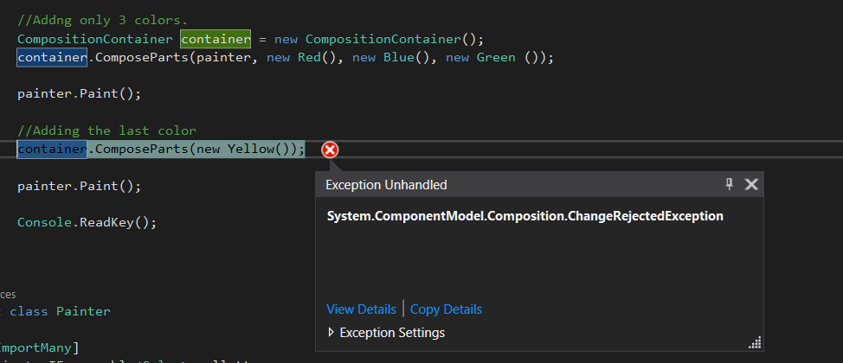

This is because one or more of our part isn’t setup to allow recomposition.

This can be fixed by setting the allowRecomposition to true on the ImportMany Attribute.

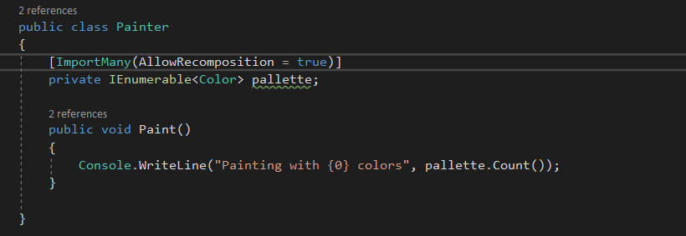

Now when we run this, everything works just fine. Our painter instance was updated live without us and they need to get a new instance of it in order to take advantage of the 4th color.

Another method for composing parts is the SatisfyImportsOnce method which will compose a type without registering it for recomposition. It composes a part one time and does not add it to the container.

What we saw with recomposition is once a part has been composed, any changes to the container will cause recomposition and the previously composed part will be updated.

Using the SatisfyImportsOnce to compose a part will do so in a way that any changes to the container will not affect a previously composed part. Basically, the container doesn’t keep reference to it. Additionally, if the part being composed to the SatisfyImportsOnce method has any exports, those exports are ignored and will not be added to the container.

Previously when we ran this code and the Painter instance was recomposed when we added he 4th color to the container. But with SatisfyImportsOnce, the part won’t be added to the container, so the container doesn’t know anything about it once it’s done composing for us. When we run this time we can see that the 4th color is not added and for both the time we only have 3 colors to work with

class Program

{

static void Main(string[] args)

{

Painter painter = new Painter();

//Addng only 3 colors.

CompositionContainer container = new CompositionContainer();

container.ComposeParts(new Red(), new Blue(), new Green ());

container.SatisfyImportsOnce(painter);

painter.Paint();

//Adding the last color

container.ComposeParts(new Yellow());

painter.Paint();

Console.ReadKey();

}

}

public class Painter

{

[ImportMany(AllowRecomposition = false)]

private IEnumerable<Color> pallette;

public void Paint()

{

Console.WriteLine("Painting with {0} colors", pallette.Count());

}

}

[InheritedExport]

public class Color { }

public class Red : Color { }

public class Blue : Color { }

public class Green : Color { }

public class Yellow : Color { }

---------------------------------------------------------------------------------------

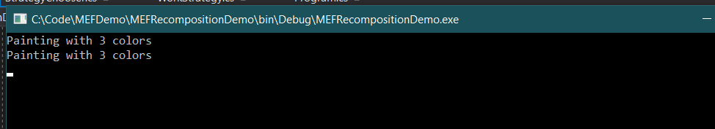

It may be important for your class to be aware of when composition or recomposition is occurred. To be notified when composition has occurred, we can have our parts implement the IPartImportsSatisfiedNotification interface which has a single method on import satisfied.

When compostion or recomposition occurs, the OnImportSatisfied method is invoked to indicate that the part is fully composed and is safe to use. Since the object isn’t in a complete state after the constructor is finished, this is a good way to validate the state of a part after composition is completed.

namespace MEFRecompositionDemo

{

class Program

{

static void Main(string[] args)

{

Painter painter = new Painter();

//Addng only 3 colors.

CompositionContainer container = new CompositionContainer();

container.ComposeParts(painter, new Red(), new Blue(), new Green ());

//container.SatisfyImportsOnce(painter);

painter.Paint();

//Adding the last color

container.ComposeParts(new Yellow());

painter.Paint();

Console.ReadKey();

}

}

public class Painter : IPartImportsSatisfiedNotification

{

[ImportMany(AllowRecomposition = true)]

private IEnumerable<Color> pallette;

public void OnImportsSatisfied()

{

Console.WriteLine("I have been composed.");

if (pallette.Count() < 1)

{

throw new InvalidOperationException("No colors were added to the pallette");

}

}

public void Paint()

{

Console.WriteLine("Painting with {0} colors", pallette.Count());

}

}

[InheritedExport]

public class Color { }

public class Red : Color { }

public class Blue : Color { }

public class Green : Color { }

public class Yellow : Color { }

}

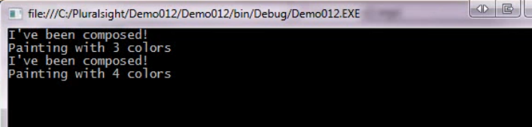

When we run with the allowRecomposition setting set to false, below is the output

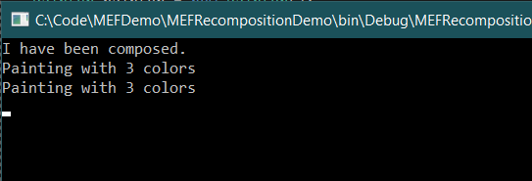

## Catalogs

Since MEF is meant to solve extensibility and considering the definition of extensible, manually adding parts really isn’t our goal. We need to be able to discover parts at runtime.

Catalogs are the discovery mechanism for MEF. Catalogs are used by composition container to learn about parts that have been discovered at run time and as the recommended approach for adding parts to the container. MEFF comes with a set of catalogues out of the box that will satisfy most of our needs.

1. type catalog -> It discovers parts from a given collection of types. Using this catalog is very similar to using to composition batch to register the parts yourself except we don’t have to actually instantiate the parts. However this catalog can easily be used as a base for a custom catalog such as one which reads from a configuration file to discover parts and in fact is actually used by the other catalogs that MEF provides.

The type catalog is also how you will manually add a part to the container when it uses a ImportingConstructor.

We will again use our WinForm app from ConstructorInjection example

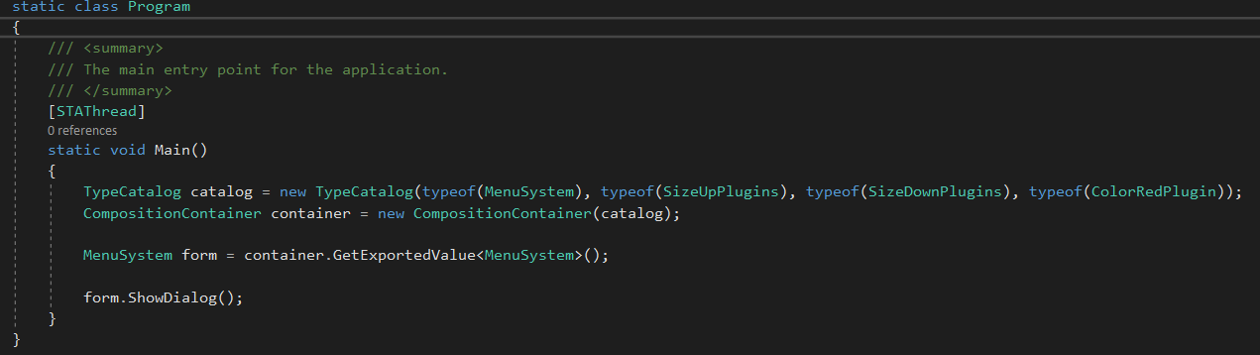

We are passing the types in the type catalog manually and since we didn’t pass ColorBlue plugins, we wont see it in the menu. Since we didn’t tell type catalog about the ColorBlue plugins, it did not came to know about it.

There is no automatic discovery happening here. Our Winform is usig a Importing Constructor which means that we won’t we able to manually add an instance of the form to the container using the previous methods like composition batch and composed parts method. So the type catalog is a great way to tell a container about the type without having to deal with the instantiation of it beforehand.

1. Assembly Catalog -> It discovers all parts that reside in a given assembly. Since an assembly is itself a collection of types, this catalog enumerates the types and uses a type catalog to do the work.

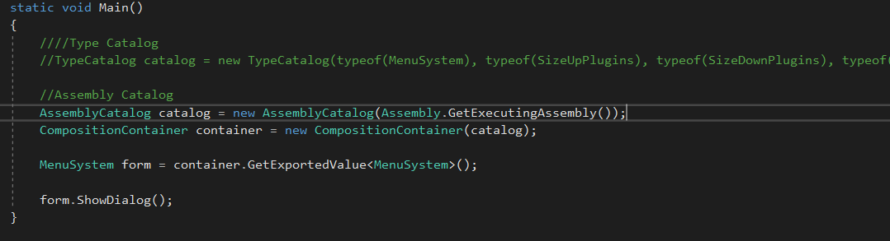

When we run, we can see all our menus since all the plugins are loaded. We didn’t have to tell the catalog or the container about any types.

With the assembly catalog, we have the access to the assembly being loaded and we are provided a way to query the catalog to see which parts were discovered.

We do this using the Parts property on our catalog which is a IQueryable.

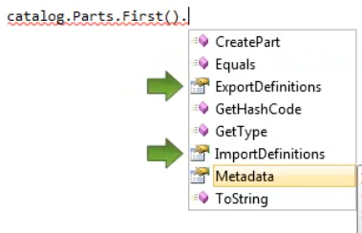

We can see the import and export definitions and also access metadata too.

1. Directory Catalog -> It scans a provided file path for assemblies and discovers the parts in each assembly. Just as the assembly catalog makes use of the type catalog, directory catalog makes use of assembly catalog.

It also provides a refresh method that we can use to update the catalog without needing to restart the application. When we call refresh, it will reeveluate the given path and any new parts will be added and parts that were removed will be removed from the catalog. Calling refresh will cause a container to recompose its parts.

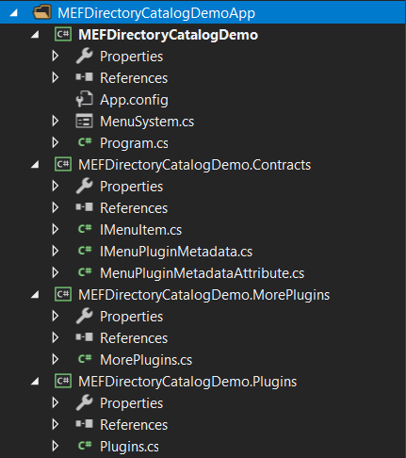

We have split our project into more real world scenario. We have plugins project to hold our plugin. We moved all of our contract interfaces into Contracts Project. All the projects makes a reference to the Contracts project. In the Build Events on the Plugins Project properties, I have added a macro to copy the plugins assembly to the demo application output folder so we don’t have to do it manually each time.

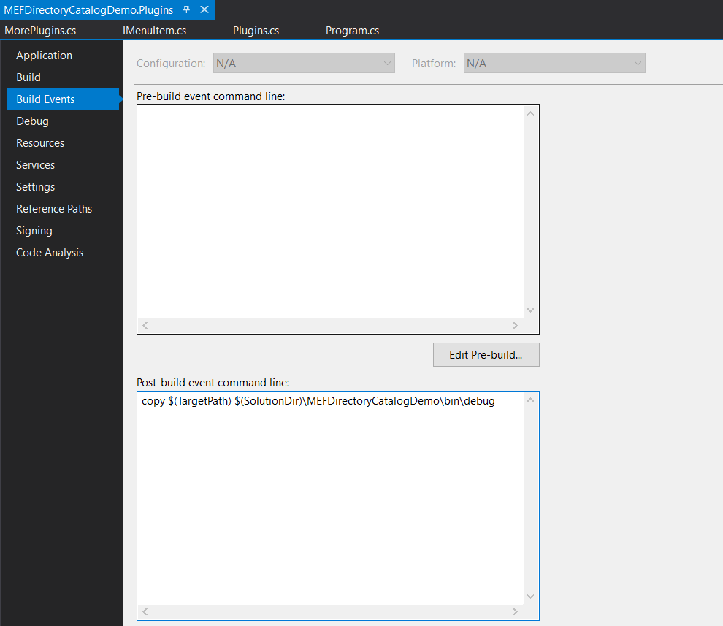

To use a directory catalog we new it up and pass it the path of the directory folder.

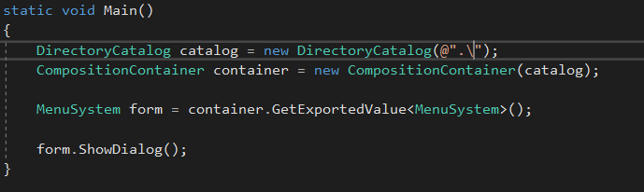

Let’s rebuild our solution and see if the plugin assembly is in our output folder.

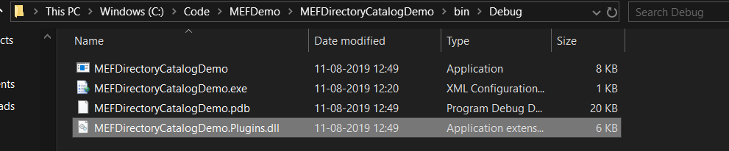

And yes, it is present.

Now when we run the solution, we get an exception at the MenuSystem.

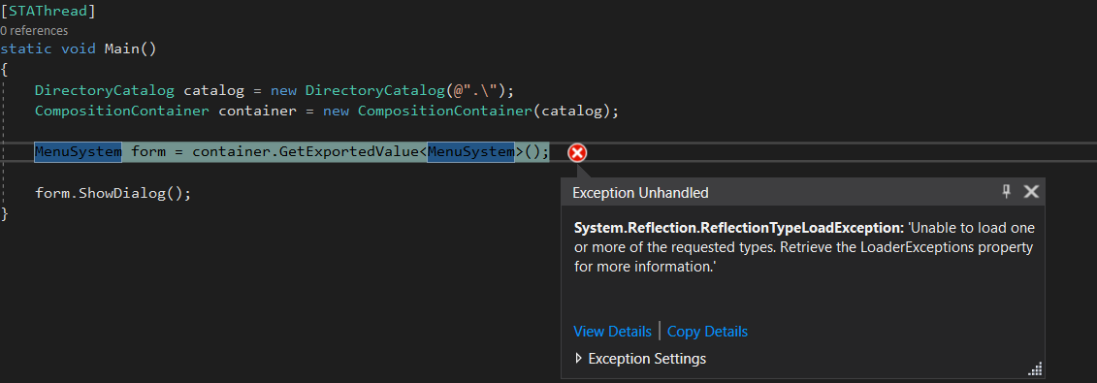

This is because it can’t satisfy our request for MenuSystem which is our form. We haven’t maked it as Export and so it happened. The reason is because the catalog couldn’t pick it up. By default, the directory catalog uses a filter that only looks for .dll extensions. Since MenuSystem is in our executable (.exe) output, it skipped over it. So, we need to update our catalog to use a filter that looks for everything.



Now, when we run, we see that it is working as normal. But the directory catalog has a feature that is useful to us, the refresh method.And anytime, we can call the refresh method to have the catalog, look at the path again and load any new assemblies that may have been added. This seems exactly like what we want for this type of application.

We have a project called MorePlugin. It has one more color menu item as Green. We will copy the More Plugin assembly to our output path while the application is running and watch it update live.

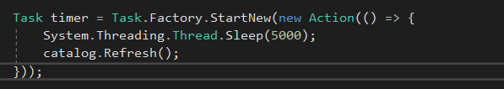

First we need to setup a task that will sleep for 5 seconds and then call the refresh method on the catalog.

The catalog also has two events that we can subscribe to. Changed and Changing.

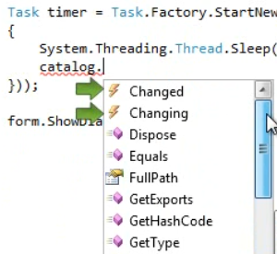

Before we run the application, we have to set our form for recomposition. It does not support recomosition currently. So we will switch back to property injection style method instead of constructor injection method and set the AllowRecomposition to true. Then we will implement the IPartImportsSatisfiedNotification interface and call our InitializeMenu method from the interface method implementation.

Then, finally in our InitializeMenus method we just have to clear the menus at the beginning before adding new ones.

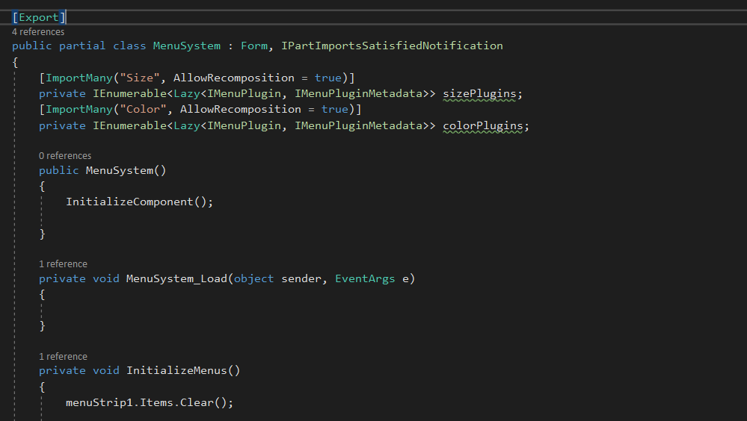

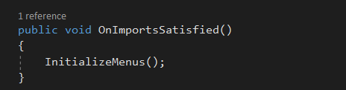

Now when you place the MorePlugins.dll into the solution directory/bin/debug folder, the app loads the Green Menu item into the color menu without even restarting the application.

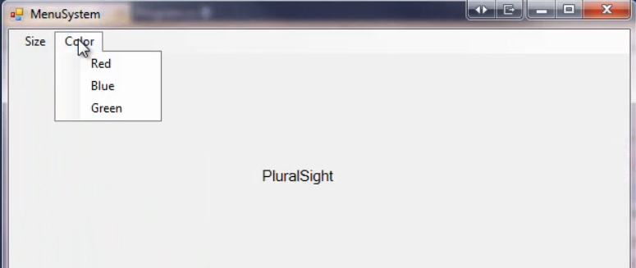

1. Aggregate Catalog

Sometimes a single catalog just isn’t enough. We need to discover parts from various sources. Since the container can only make use of a single catalog, we need a way to let the container know about all of the parts discovered by multiple catalogs. To do this, we employ the Aggregate Catalog. We supply the Aggregate Catalog with all of the other catalogs being used and then we supply the Aggregate Catalog to the container.

The issue we had using the directory catalog of placing the other plugins dll into the Debug folder manually, this might be a good opportunity to use AggregateCatalog.

Instead of changing the DirectoryCatalog filter to include everything, we can use a TypeCatalog to make the container aware of the MenuSystem type.

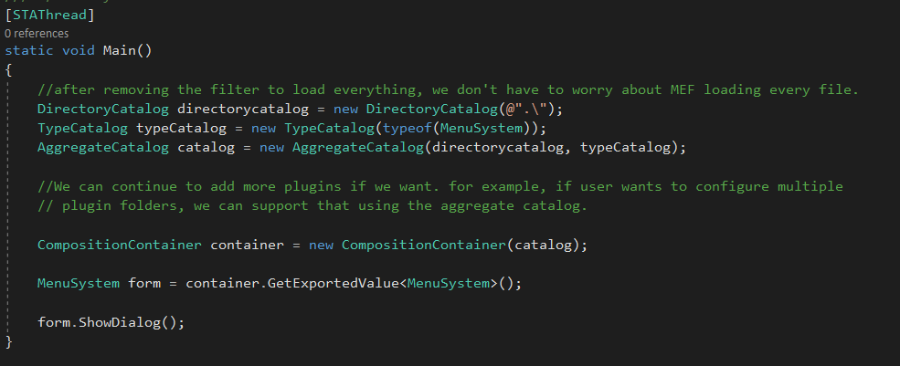

There are times when you want to avoid having a part get discovered and added to our catalog. An example of this is when subclassing a part maked with inheritedExportAttribute, but not for the purpose of creating a new part or if you plan on manually adding parts to a container.

To prevent discovery by a catalog we decorate the part with [PartNotDiscoverable] Attribute.

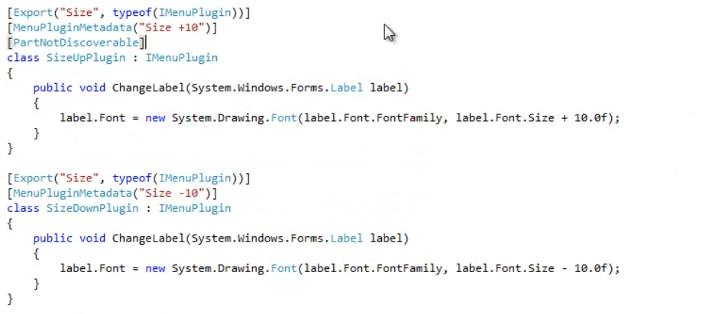

Just like that and that part will not be discovered.

## Querying the Container

What goes into the container will eventually needs to get back out. The container provides us with a few methods for getting items back out of the container.

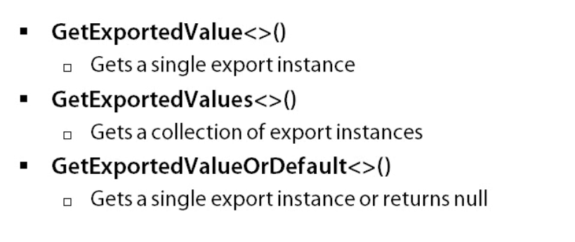

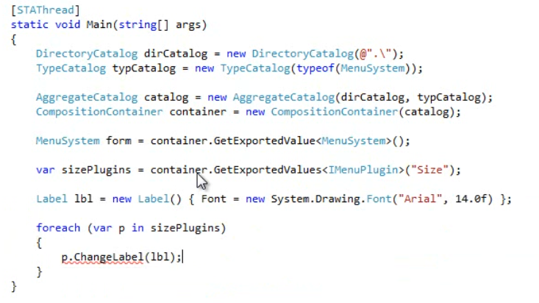

Then we have the lazy methods

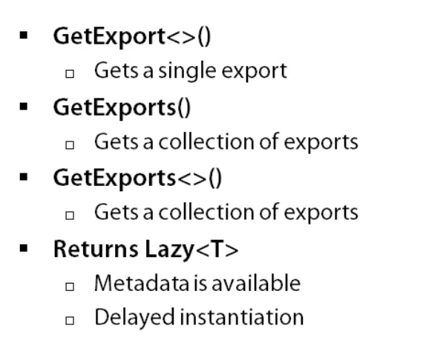

These methods do the same as previous methods, except that they will return an instance of a generic lazy type. The benefit of using the Lazy methods is that we get access to the metadata and the instance of the export won’t be directly available until the value property is first used.

Since we get metadata with GetExport(), we can make use of it to filter plugins.

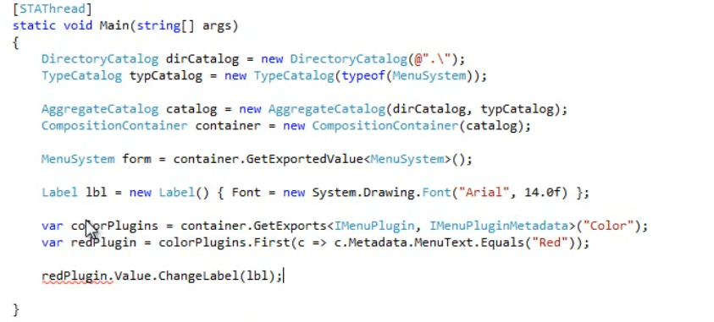

# Part Lifetime and Scope

Understanding lifetime, scope and ownership of parts is very important especially when dealing with parts in a multithreaded environment.

We are dealing with parts with half state. So, these are important to understand to avoid memory and threading issues.

All parts that go into a container have specific lifetime and scope. Because we are building systems that could be extended after it ships, we need to understand their scope and their implications. Parts can have

1. Shared scope – It is a single instance of a part that the container uses to satisfy all imports and requests for that part. This means that how many times a part is requested or used to satisfy an import, the same instance will be used which can become a problem since the part can potentially be changed by any requester.
2. Non-shared scope – The container uses new instances of part to satisfy each import request. When using non-shared parts, we don’t have to worry about changes being made by other requesters. But this means that new instances are created on every single request or import. We could potentially have hundreds. If not properly managed, we could end up with memory leaks.

We can control the part go both as part authors and as part consumers. We do that using a creation policy.

For exports, we use the PartCreationPolicy Attribute which takes in one of the creation policy enumeration.

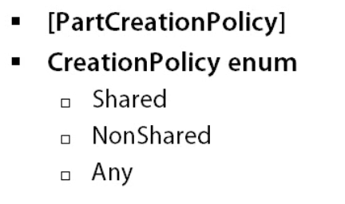

By default, parts are scoped to Any which allows a part to be used as shared or non-shared as defined by an import. If neither the export nor the import defines a creation policy, then the default will be to use a shared instance of that part.

## Part Scope

We have a BeanBag class that has 2 methods AddBeans and RemoveBeans. The constructor of this class sets the count to zero.

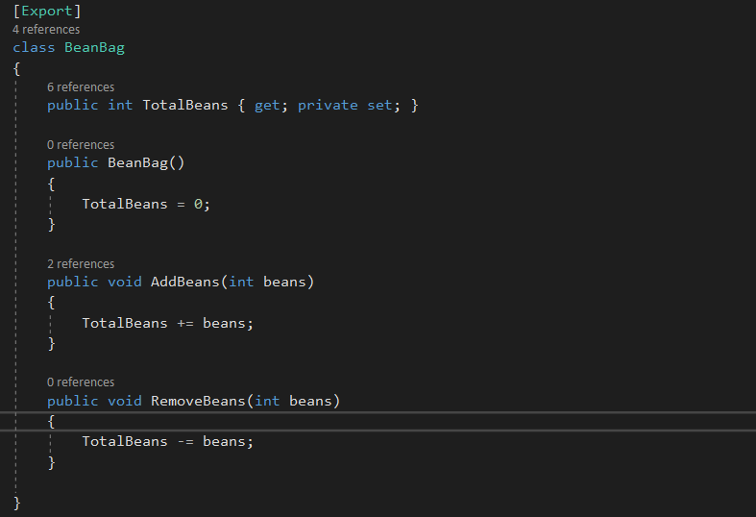

Then we have 2 BeanCounter class as BeanCounter1 and BeanCounter2. Both of them has a CountBeans Method that adds beans to the BeanBag class. Each class has its own beanbag field marked as an import.

Also both the BeanCounter class is marked as export so that we can request from the container.

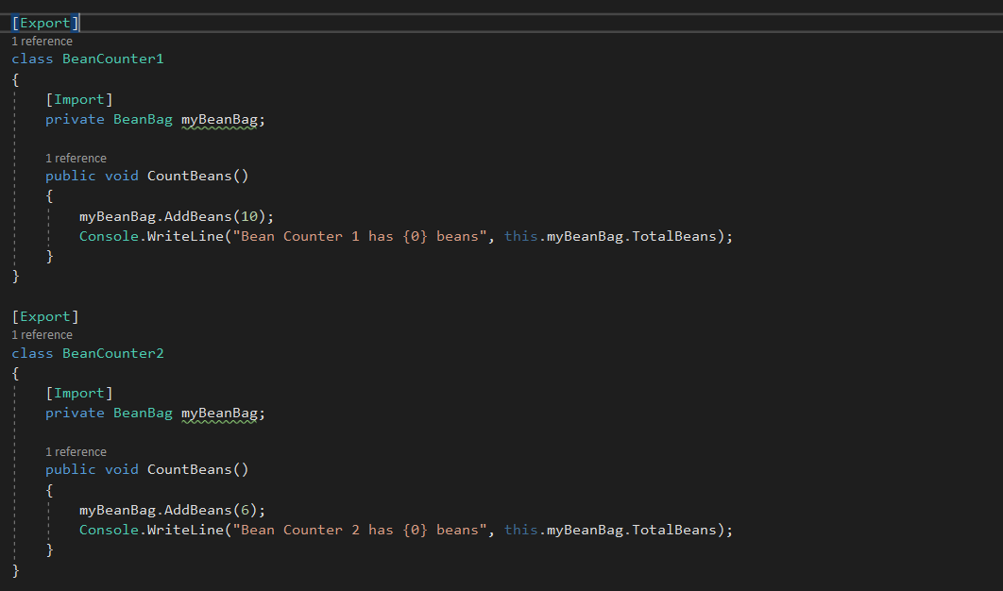

The main method is pretty simple.

We build an assembly catalog and consume it in the container. Then we ask the container to get the exported value of each BeanCounter and then call the CountBeans method on each .

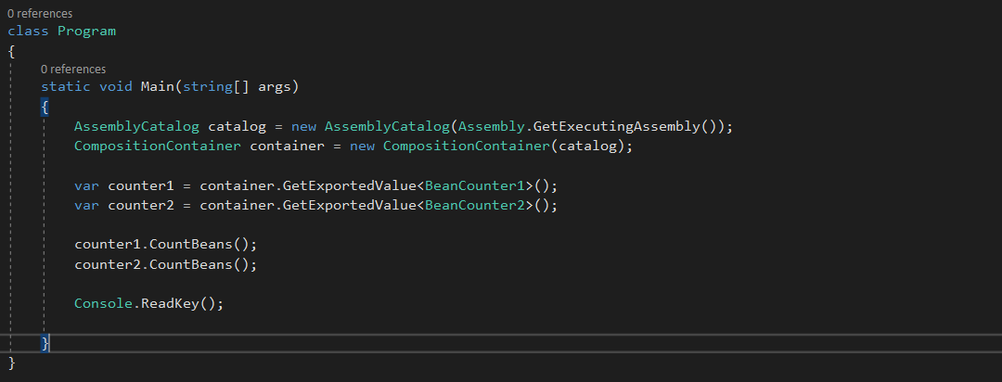

When we run this, we get the below output. We add 10 beans to the Counter1 class and 6 to the Counter2 class.

And this is why the total ends up to 16. This is because, unless otherwise instructed, MEF will default the scope of parts to shared, meaning only single instance is used. So, this is why only a single instance of the BeanBag class is used and the beans gets added to the same instance. This is why we see the total count as 16.

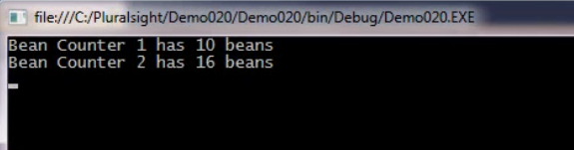

----------------------------------------------------------------------------------------------------------------------------------------

What we want here is that we want each counter to have its own beanbag. So, let’s specify a creation policy as NOnShared on the BeanBag class.

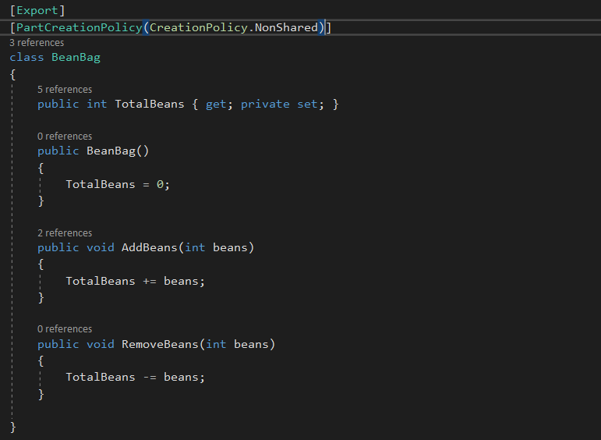

When we run this, we now see the counter1 has 10 and counter2 has 6 beans. This is becaue each counter is now getting an instance of their own beanbag.

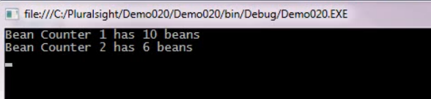

----------------------------------------------------------------------------------------------------------------------------------------

For imports, we can require that an export have a specific scope. Wo do this through the Import Attribute rquiredCreationPolicy property. And we can set it to one of the CreationPolicy enumeration value.

If an Export is marked as a Shared Instance but an import is requiring a non-shared instance, then the import will not be satisfied and an exception may occur. On imports we can force the scope.

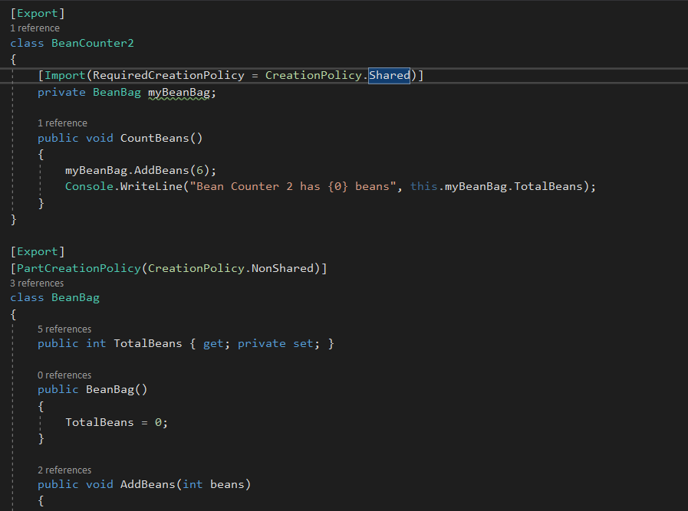

We have made the scope in the counter2 class as shared for the import whereas the export still has the non-shared as its creation policy. When we run this we get an exception.

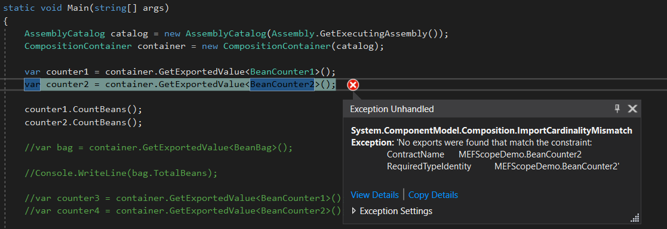

Let’s fix this.

We have set the RequiredCreationPolicy of the Counter2 BeanBag Import to NonShared and removed the PartCreationPolicy Attribute from the BeanBag class.

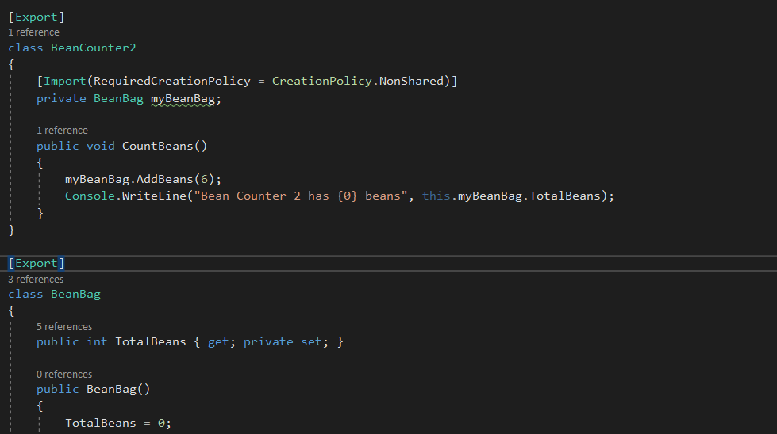

When we run this now, we see the same expected result of 10 and 6 as the counter values.

Now let’s ask for another 2 instances of the counter.

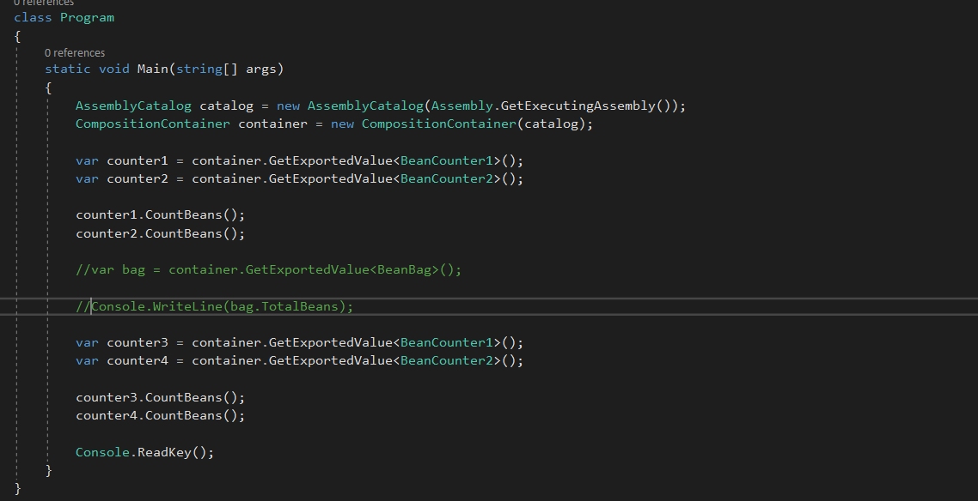

When we run this time, we see that the counter 1 and 3 are sharing a beanbag instance and so are counter 2 and 4.

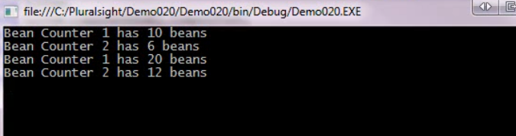

Even though we set BeanBag as non shared part, both of our counters are shared because we didn’t tell MEF otherwise. And MEF makes them shared by default. Now you will say that we marked the counter2 as non-shared. But that would not work as our BeanBag class does not set the PartCreationPolicy Attribute and MEF exports this class with a shared scope by default.

So when MEF composes counter1 and counter2, they get new instances of the BeanBag (because counter2 Import was maked with Non-Shared). But when we request 2 new instances of BeanCounter1 and BeanCounter2, we get back the same shared instances of the bean counters which still have the original references to the beanbag.

Let’s set the Counter2 as a nonshated Part and see what happens. We do this by using the PartCreationPolicy Attribute.

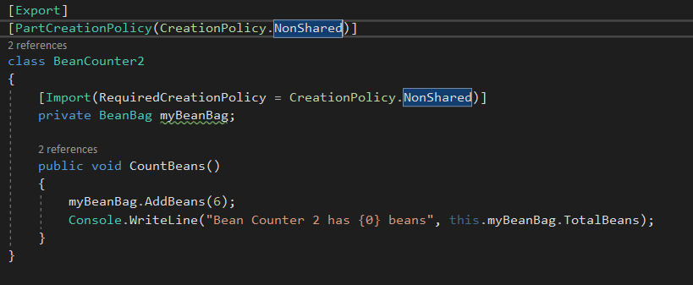

Now when we run this, we should see that the counter2 and counter4 should get a new instance of the BeanBag and show the count of 6 each. But the counter1 and counter3 should have a shared instance and shows the result as 10 and 20 respectively.

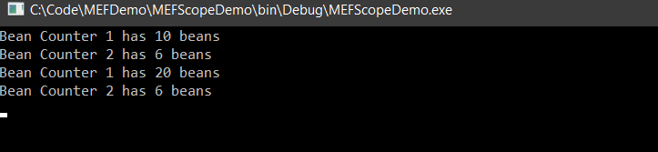

And viola, that’s what happened.

Now, lets make counter1 a nonShared part but we are leaving the import alone.

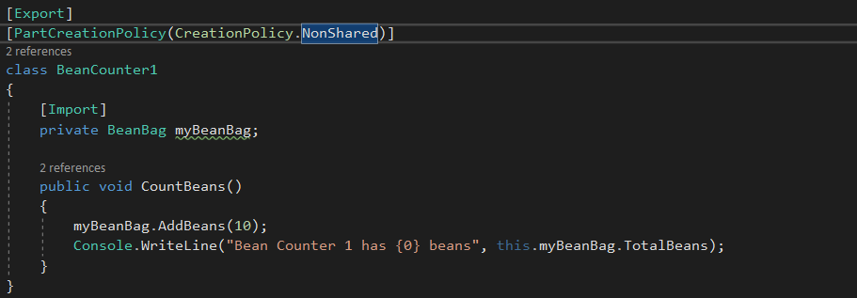

When we run this, we see the below output.

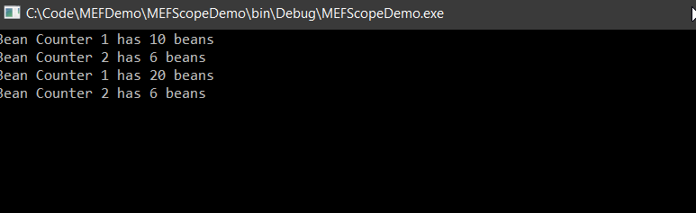

The result didn’t change. Even though we set BeanCounter1 to a Non-Shared part, we are not specifying a creation policy in the import and BeanBag isn’t specifying a part creation policy either. So by default as we know that MEF marks them as shared scope, the counter1 beanbag instance shares the instance.

## Part Ownership

Let’s understand how the container handles part references now. The container won’t hold the reference to a part that it creates except under a few conditions.

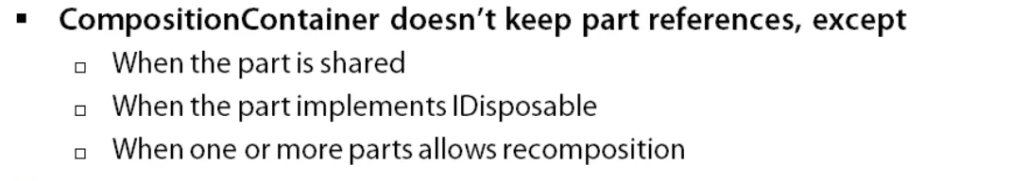

The container won’t keep a reference to a part that is manually added either but it keep references to any parts created to satisfy imports on the manually part assuming one or more conditions are true.

The parts that the container does keep will always be owned by the container. It will never transfer ownership to a requester. This means that the container will handle the disposal part of instances that gets references to. But its how the container will handle those references and the disposal that wee need to be concerned with.

Parts created by the container have a lifespan scoped to a container .

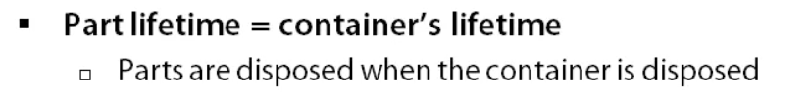

But this could lead to a memory problem if you are not careful.

We have created a DisposablePart class implementing the IDisposable interface and we have set it to be NonShared.

Inside it, we have a dispose method and a Finalizer setup to let us know when of these events occur.

In the main method, we will loop 10 times and request an instance of our part from the container and then clean it up by setting it to null. Below the loop, we will tell the Garbage Collector to collect and wait for finalizers which will clean up any non-referenced instances.

Then we will dispose the container.

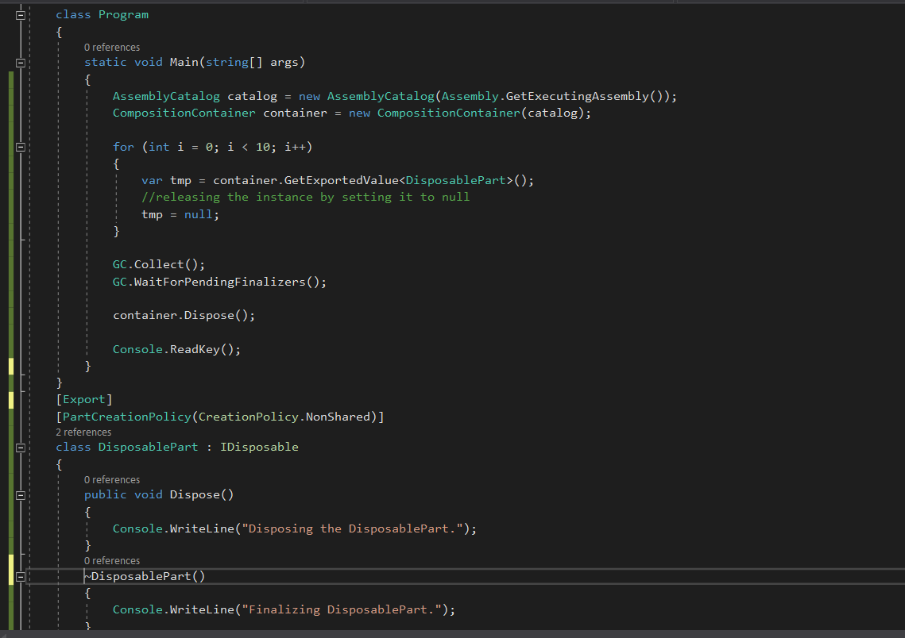

When we run we see that only when the container is disposed do the parts gets released. The container class dispose on all the references. The container kept the reference to all the 10 instances we asked for. We have 10 new instances as the DisposablePart class has an Export Creation Policy of NonShared.

So, when the garbage collector was run, it didn’t find anything to clean up and hence the finalizer never gets hit.

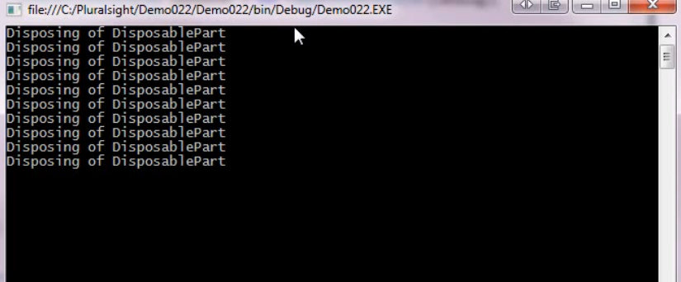

Let’s remove the IDisposable interface and try again.

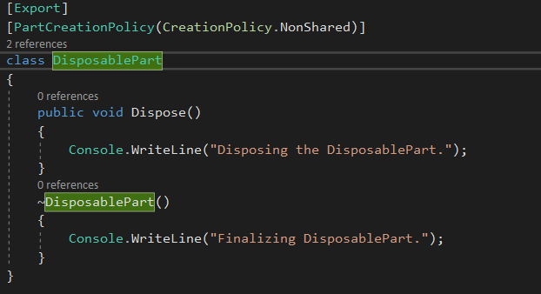

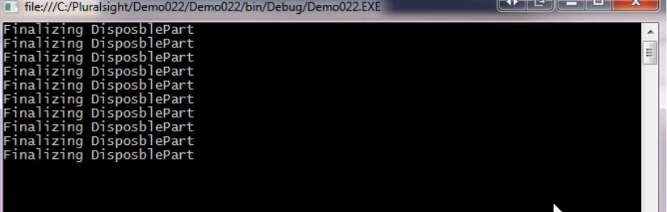

Now, we see that after the loop, the garbage collector came in and cleaned up. The container didn’t keep the references to the parts because they are no longer marked as disposable so they were able to be cleaned up before the container was disposed.

## Cleaning our Parts Manually

To keep our applications from being memory hogs, we can do one of two things.

1. Release object graphs ourselves or
2. Use nested containers.

Let’s start with few object graphs and see what the container does with it.

We will start with 3 exports.

1. Shared
2. NonShared
3. Non Shared IDisposable

If we asks the container to release these part instances, the shared part will be ignored. The container will hold its references until the container goes out of scope.

The non-shared part will be ignored too since the container didn’t keep a reference to it, so there’s nothing to release.

The non-shared part instance that implements a IDisposable would have this disposed method invoked and it would be removed from the container.

So what about a non-Shared part that implements a IDisposable that has a dependency on another non-shared Idisposable part? When we ask the container to release the parent, both instances would be disposed off and removed from the container. MEF handles a releasing of dependencies for us.

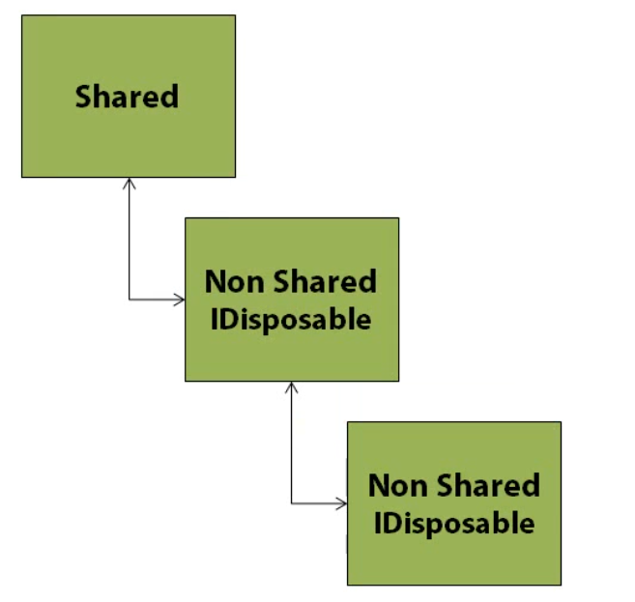

A shared part with dependencies on non-shared parts will be ignored. Since the shared part won’t be disposed up until the container is disposed, MEF will leave these dependencies alone. MEF is smart enough to not put our shared part in a non-stable state.

For this demo we have 3 class ClassA, ClassB and CLassC and all of then implements the IDisposable interface. ClassA imports ClassB and ClassB Imports ClassC. So this is a demo of non-shared idisposable part dependencies on non-shared idisposable parts. So, if we dispose the parent ClassA the dependencies should also get disposed.

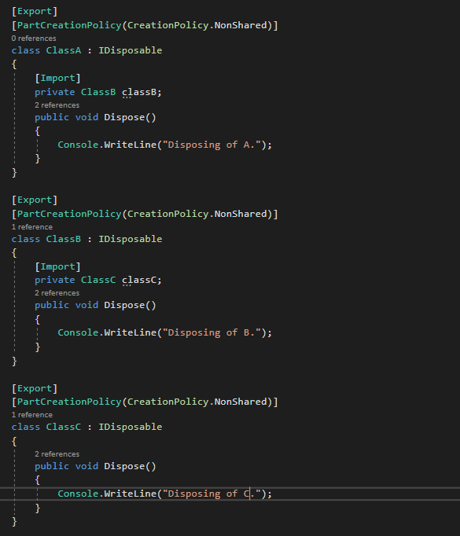

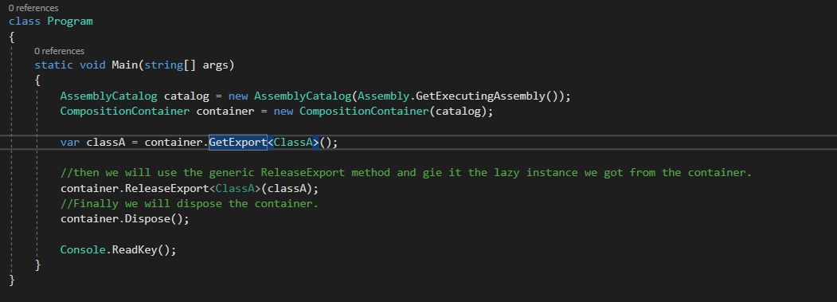

When we run, nothing happens.

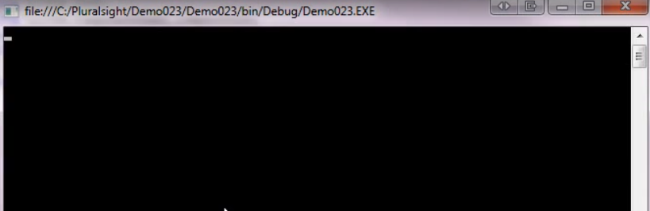

This is because we didn’t cause any instance of our part to be created so there isn’t anything to release.

So, we will use the value property on our lazy instance which will create our part instance for us.

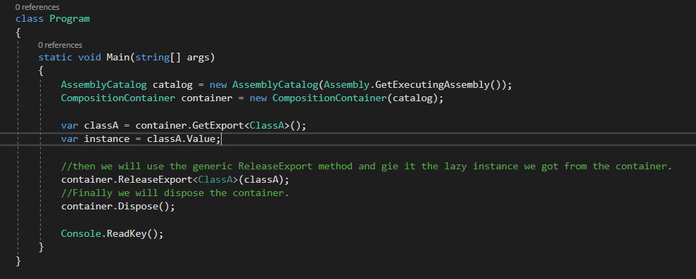

Now, when we run this, we see that the classC is disposed first followed by the classB and then finally the classA. It disposed the dependencies first before disposing the parent part. Since we called the ReleaseExport on ClassA, both the dependencies export parts were disposed first as ClassA being the parent of both of them.

Now let’s set ClassB to a shared part and try again.

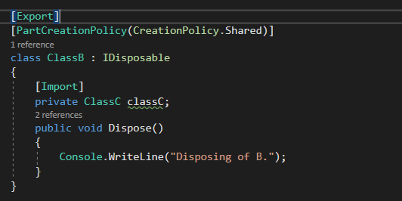

Now when we run this, we see that the A was disposed first followed by B and then C. We just changed the ClassB part creation policy to Shared. The dependencies are still the same.

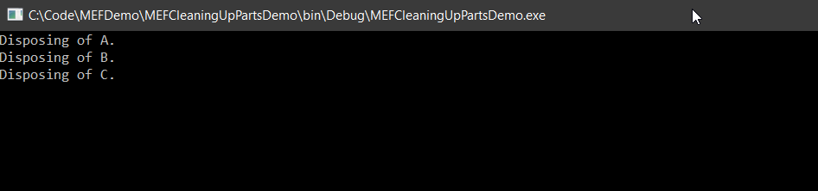

What happened is that, when we ran, ClassA gets disposed and released because of the call to ReleaseExport called on classA instance, but classB and ClassC didn’t.

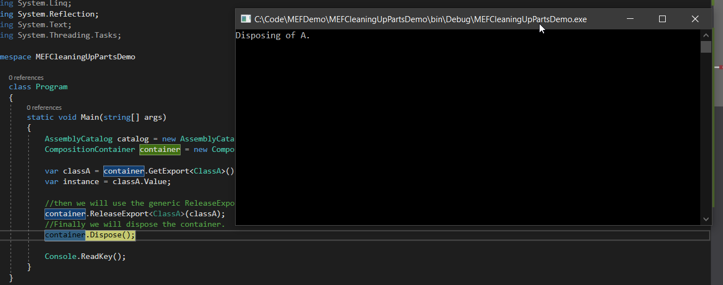

ClassB and ClassC gets released only when the container gets disposed.

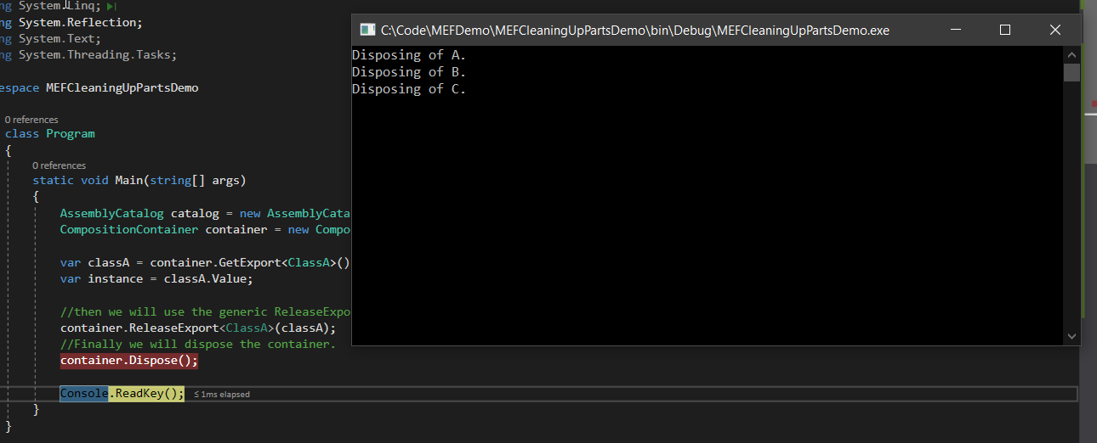

This is because, shared parts can’t be released until the container goes out of scope because other parts could be referencing them and that would put those parts in an unstable state.

Notice that when the container is disposed, We see that B gets disposed followed by C whereas before they were release from the bottom of the chain.

There is not set order in which parts are disposed so you should never try to make use of a part import in the dispose method because they might have already been disposed.

## Cleaning up Parts with Nested Containers

If cleaning up object manually seems like a lot of messy work, there is always an option to dispose off the container to clean up everything. Since parts are scoped to the lifetime of the container, this would do the job. But it means that we lose our container and everything in it.

So, we probably want to release certain objects, dumping the container isn’t an ideal solution.

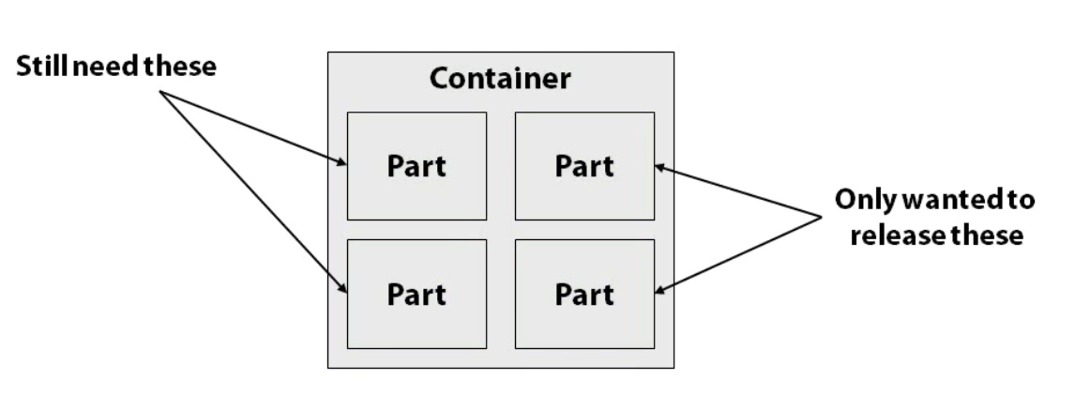

What we can do then is create a child container that will hold the subset of part and will use the child container to do our work. Then when we are done, we can clean up the objects by disposing on the child container.

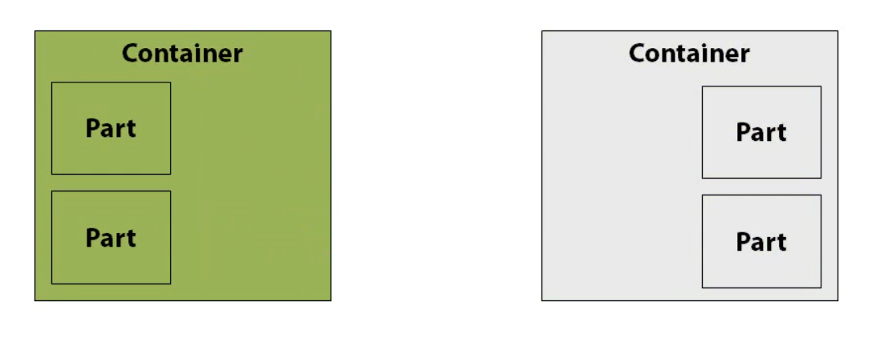

It isn’t really necessary to nest the container, we could just as easily create a new container and add all of the parts just like the first container. By nesting in the container we allow the child container to resolve imports using parts from the parent container

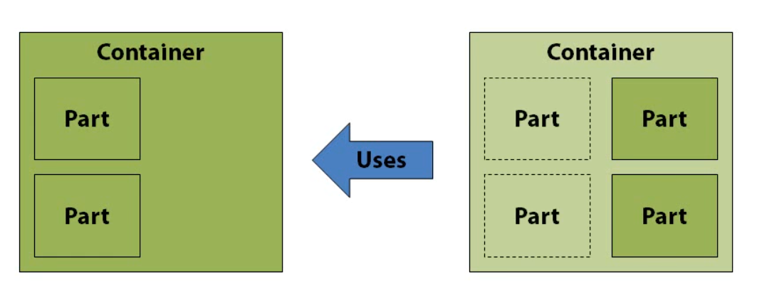

Let’s say we have a shared part in the parent container that will need to be used by parts in the child container. If we add all of the parts to the child container, we would end up with a second copy of the shared parts that would then be used to resolve imports on the child container.

It works but it isn’t optimal and may have unintended side effect.

For this Demo, we have setup three classes, Logger, TemporaryWorker which uses logger memoryIntensiveResourceLoader, and MemoryIntensiveResourceLoader which also uses logger.

All the class implements IDisposable interface to notify us when the part is disposed.

TemporaryWorker and ResoureLoader are used only in a limited scope so they don’t need to be around for the lifetime of the application, only long enough to do its work and move on. These two classes are setup as non shared so we could have many instances of them in memory which wold grow the memory usage of the application overtime.

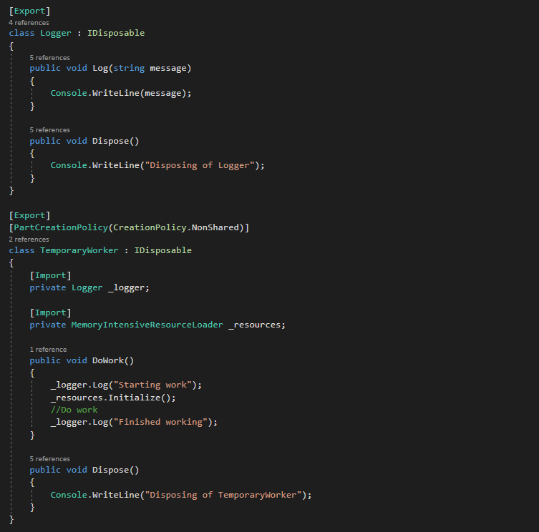

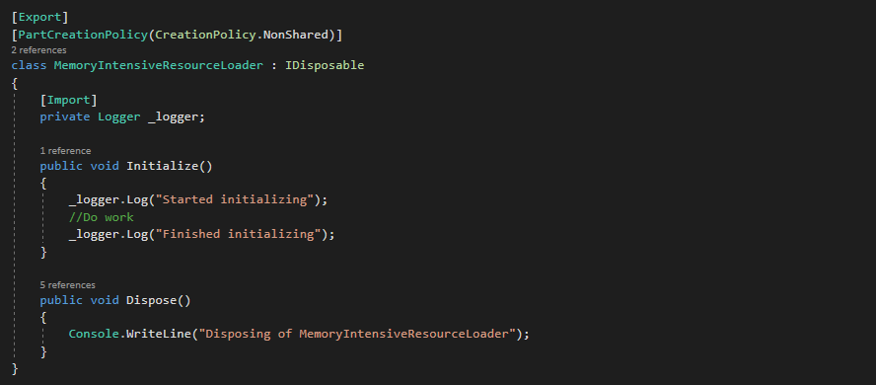

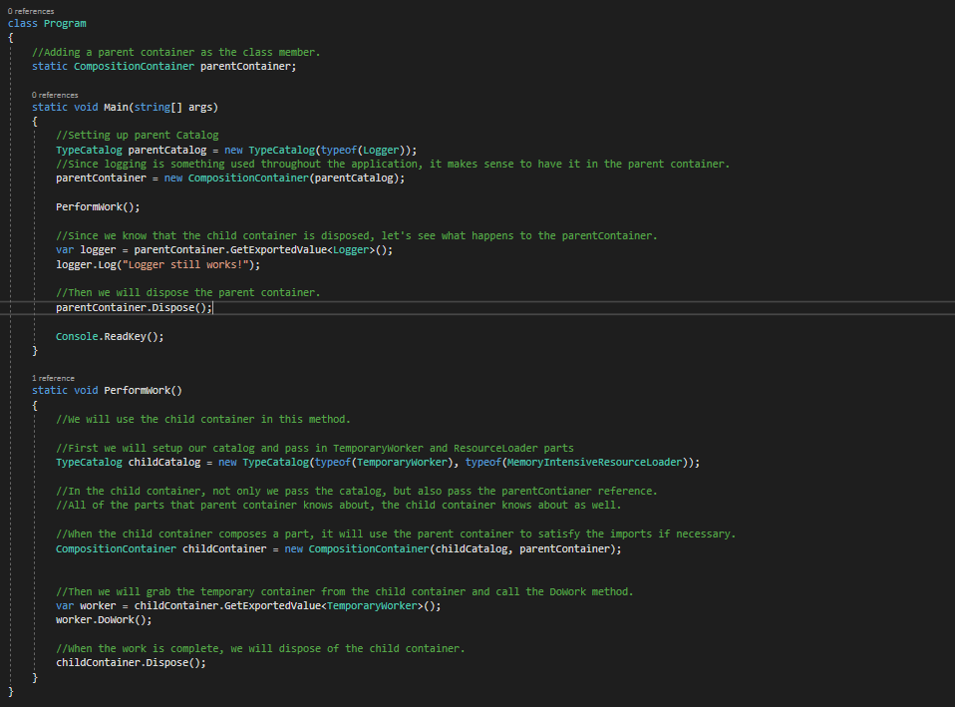

When we run this, we see the below output.

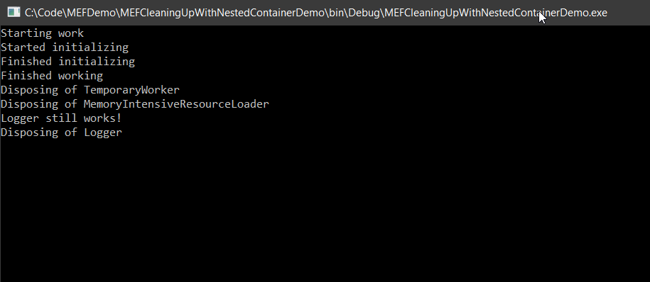

We see the log output. The temporary worker is doing its job and resource loader is too. So both of these parts are able to import logger even though it was contained in the parent container. The child container use exports fro the parent container to satisfy the imports on the parts that it was composing. Then we see that the child container is cleaning up itself and disposed its two parts. Looks like our logger was till available in the parent container and then it disposes off the logger too by disposing the parent container.

We can call PerformWork method multiple times and do the work without worrying about memory comsumption or having to clean up instances manually. We can dump the child container and then move on.

# Debugging

## Quick Tips and Exceptions

1. Make sure you have the right cardinality set up on imports. If your are expecting multiple items but aren’t using the ImportMany attribute, you are going to have some issues.
2. Verify the catalogs are picking up exports. If you are expecting many exports but are actually getting no exports, then the catalogue might not have been set up correctly. Use the debug visualizers to see what the catalog is finding and what made it into the container. Also check that parts that aren’t marked are ignored.
3. Verify Contracts. Start with the imports and compare to the exports or exports that you are trying to match. Is it the correct type, are there any typo’s in the contract name. this can be the cause of missing exports as well as too many exports. Be sure you are following contracts best practices.
4. Make sure your parts are actually marked as exports.
5. Pay attentions to the exceptions that are thrown. They are the good starting point for trouble shooting your MEF problems.
6. Most common exception you will run into is ImportCardinalityMismatchException which is thrown when the cardinality on the import does not match to that of the export. You also get this when requesting a part from the container that the container does not know about.
7. ChangeRejectedException occurs when one or more parts are getting rejected during composition. This usually occurs during a recomposition when changes have been made to the container. For example, a part was removed but another part wasn’t put into its place.
8. CompositionException occurs when one or more errors occur during composition in the composition container. For example, a part without a default constructor that doesn’t use the importing contructor attribute causing that part to be uninstantiable.

## MEFx

If trying to manually debug, it seems to be daunting then you are in luck because there is an easier way to get the details about what MEF is doing in your app.

MEFx stands for Managed Extensibility Framework Explorer is a command line tool tat can be used to diagnose what’s going on with MEF and your part composition.

To you MEFx, you only need to tell which assembly to examine and what actions you want to take. We do this using the provided switches. To specify which files to examine, we can use the following switches.

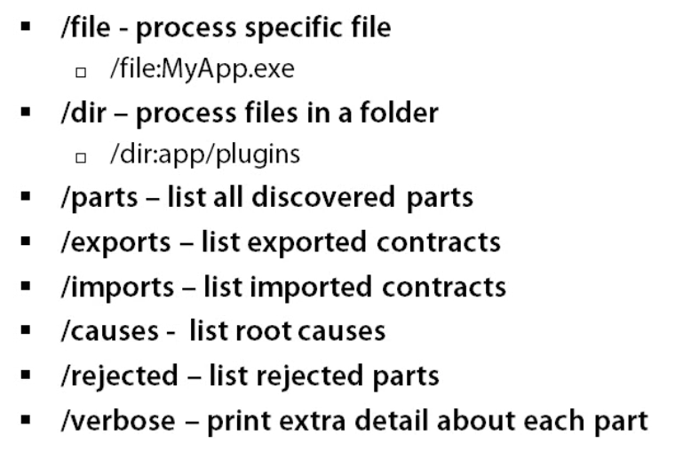

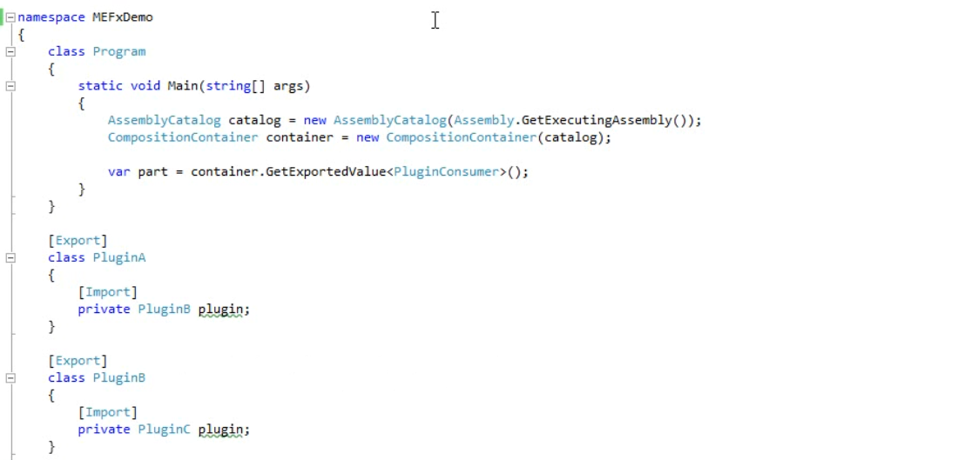

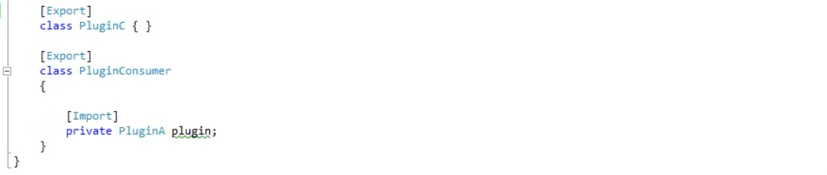

When we run this nothing happens and everything works fine.

Let’s now change plugin C and add to it a ContractName. This should cause an exception when we run again.

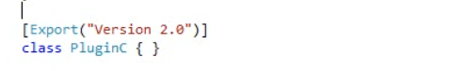

As expected, we get an exception.

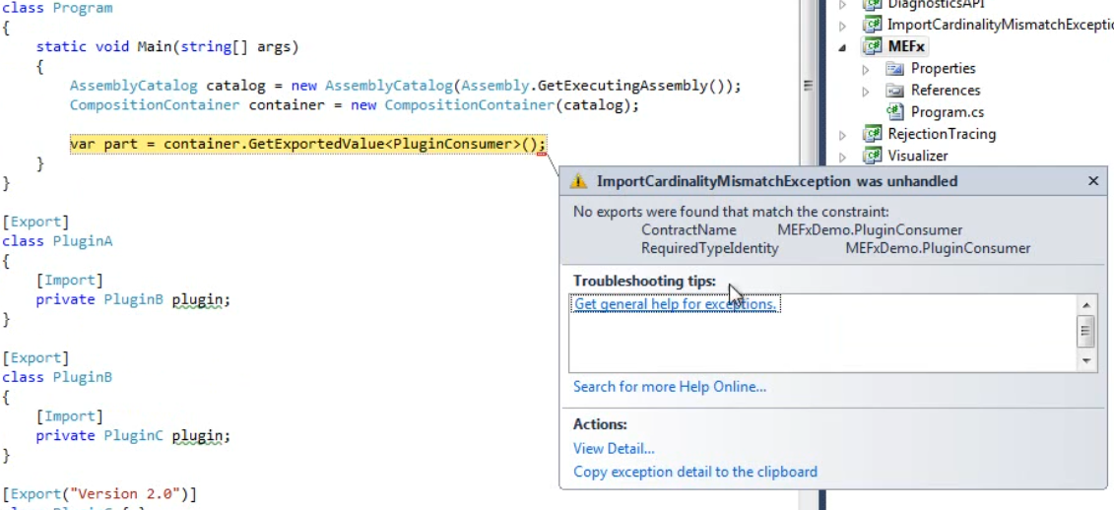

But the exception details aren’t helpful.

So, now let’s try to examine it with MEFx.

For simplicity, I have copied output from the project to the MEFx folder

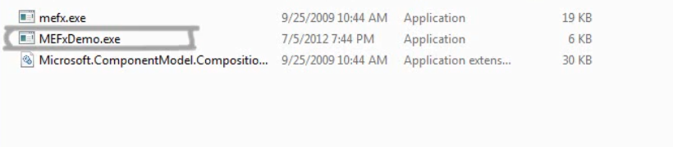

Because we got a cardinality exception, let’s start by examining the parts.

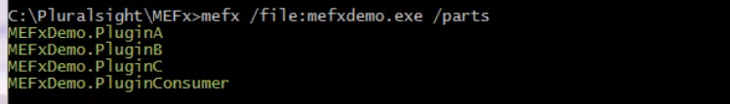

All parts are listed so we know there isn’t a problem with discovery. This must mean that one or more parts were rejected.

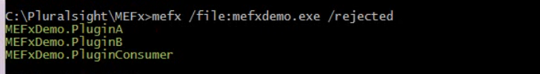

So, now we see that all parts except plugin C are rejected.



So, when we examine the causes switch we see that pluginB is causing the problem.

Now lets use the /verbose switch in there and see what is actually going on.

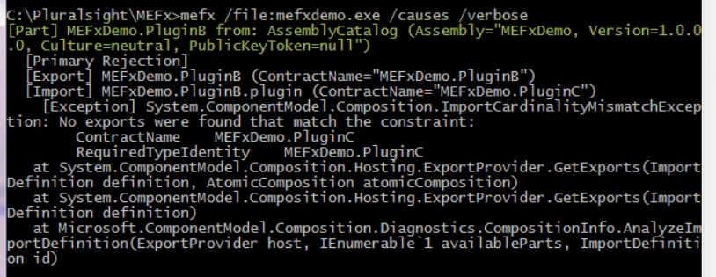

First we get the details about our part, where it originates and we can see that it is the primary rejection in the chain.

Next we get the details about the export and import definitions. We can see exactly how the part is being exported and the contracts it is using. We can also see which imports it has and their expected contracts.

It looks like we are importing pluginC and under that we can see that an import cardinality exception occurred.

Since all the signs are towards PluginC, let’s see what its doing using the type switch.

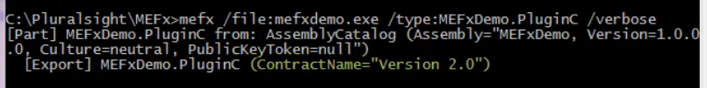

Ahh, now we see the problem. The contract Name doesn’t match to a pluginB is expecting. From here we can go on and fix it.

If you want a big picture, we can use the part switch and the verbose switch and examine all of the details in single go.

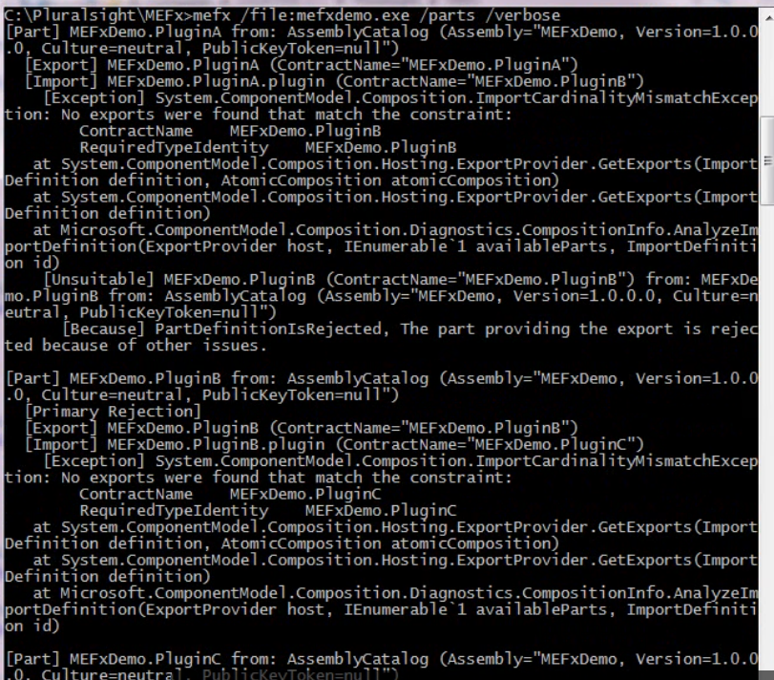

## Diagnostic API and Tracing

As great as the MEFx is, it won’t always be possible to run it against your code especially if your code is out in the wild or on a production server you don’t have access to.

Using the provided diagnostics assembly that comes with MEFx, brings us the same level of detail that MEFx gives us but through our code, so we can incorporate information into our logging.

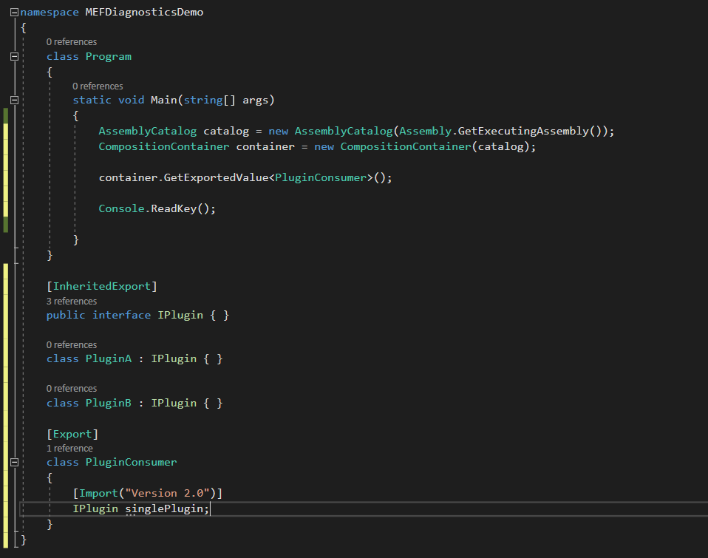

We will start by adding a reference to the Microsoft.ComponentModel.Composition.Diagnostics.dll to the project.

This dll can be found where you have extracted MEFx. Then we put the GetExportedValue code into try catch block.

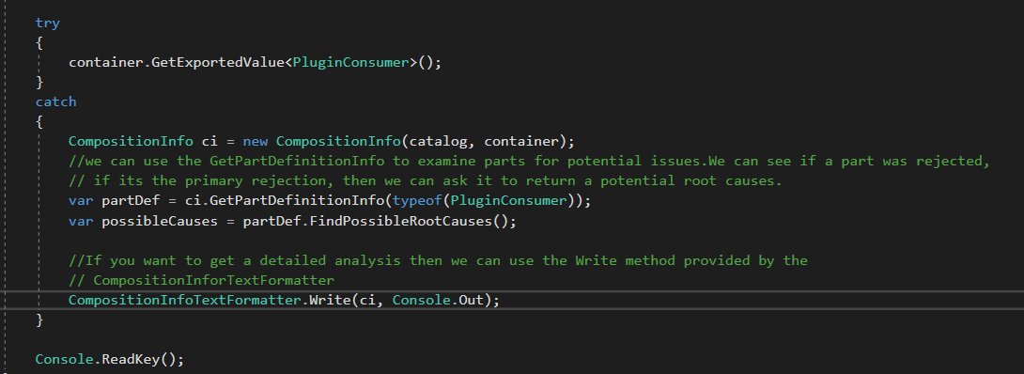

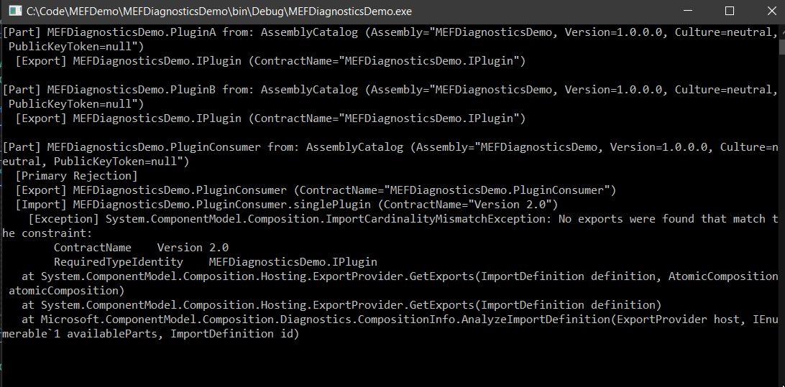

MEF also provides a level of Tracing using the standard .NET tracing. When a part is rejected, MEF will write a trace message that includes a part name, the reason and which import cause a rejection.

All we need to do is enable tracing in the configuration file and we are done.

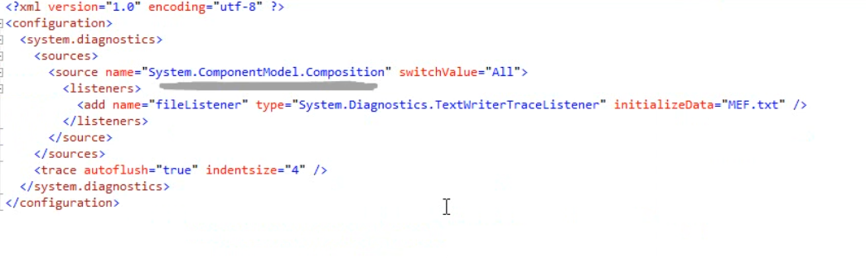

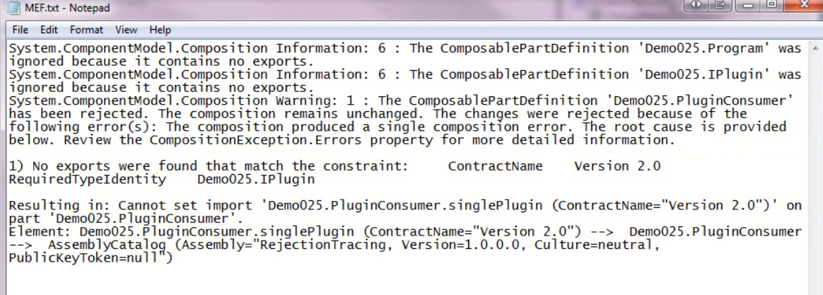

# More MEF

## Filtered Catalogue

A filtered catalogue is one that allows us to restrict which parts are available to the catalogue. It is most useful when working with nested containers when we only want to load certain parts.

Filtered catalogues doesn’t comes with MEF. We have to build it ourselves. There are various ways to do it. The way we do it is to create a FilteredCatalog class and inherit it from ComposablePartCatalog which is a primitive type from the primitive layer.

In the constructor, we will take in a catalog that we will apply the filter to, and then a generic func that takes in a composable part definition and returns a bool.

By taking a COmposablePartCatalog as parameter, we don’t have to write code to perform discovery ourselves, and let’s us use any type of catalog. Think of our FilteredCatalog as a wrapper.

We use the generic Func to determine if the part should be included or not. Next, we will set up our method that will perform the filter query and return a list of acceptable parts. To do this, we just use the linq query against the parts property on the catalog which is a IQueryable of ComposablePartDefinition.

To determine if we keep it, we call out the inclusive filter func that we received through the constructor. Then we need to override the parts property and then the getter will return a call to the FilteredParts method. And we are done with the FilteredCatalog class.

To use a catalog, we need a method that performs a query to determine if the part is acceptable. So, we will set up the CheckPartIsTemporary method which will take in a ComposablePartDefinition and return a bool.

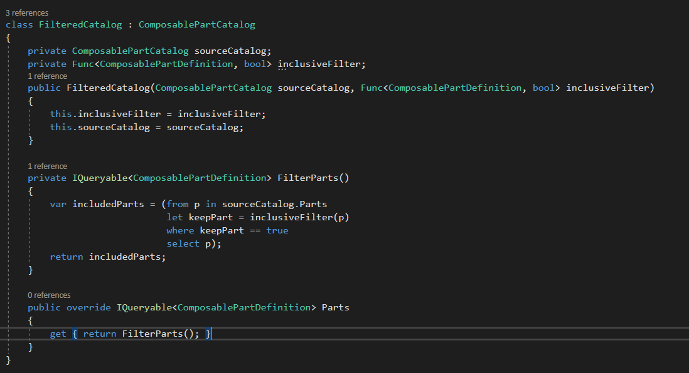

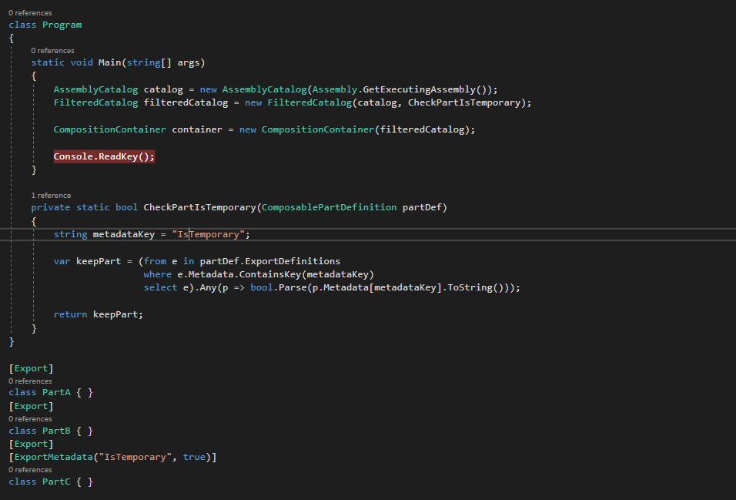

When we run, we only see the that PartC is discovered in the container whereas assembly catalog contains all parts.

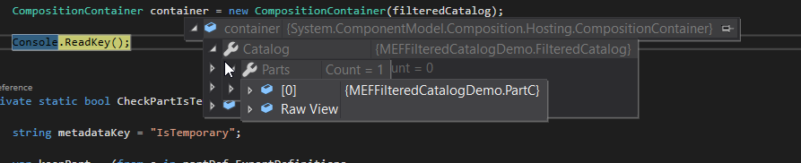

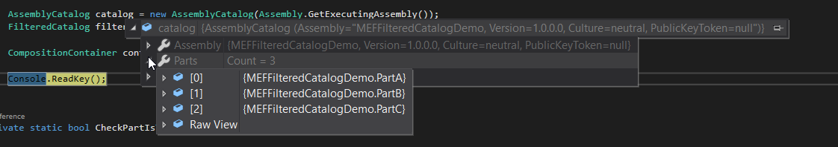

FilteredCatalog prevented the other parts from being provided.

## Custom Programming Model

We will create out custom programming model that lets us declare our exports and imports in the config file so we don’t have to mess with our code. To accomplish this, we have four major components that we have to build.

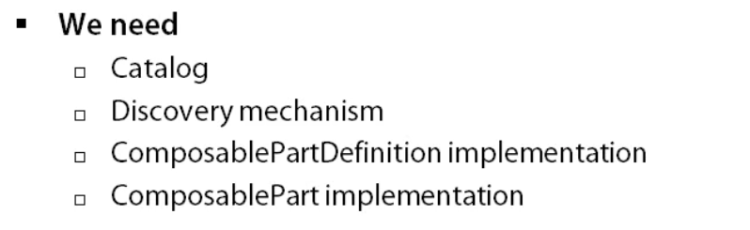

A catalog uses a discovery mechanism to find available parts and their definition so it can provide them to the container.

Then we need to build the discovery mechanism. In our case, this will be a strongly typed configuration section that will read from our custom configuration settings in the config file.

A cataog provides a Parts property which is a generic Iqueryable of ComposablePartDefinition. So, we need to create a custom a custom ComposablePartDefinition implementation. This will contain all of the information about the part including metadata.

When it’s time to instantiate an instance of the part and compose it, we will need to return an instance os ComposablePart. So, we will be building an implementation of ComposablePart as well.

-----------------------------------------------------

Our discovery mechanism is a set of nested classes that implement elements of the configuration section and add appropriate decoration on properties for the configuration network to deserialize our settings from the configuration file. The four main classes here are:

1. ConfiguredParts -> it is our top level class which holds a list of parts.
2. PartConfig -> this holds the details about the exports we defined including type and contract name. and it also contains a list of imports and metadata.
3. ConfiguredPartMetadataDefinition is a key value class that we use to define metadata for a part.
4. ConfiguredPartImportDefinition -> it is a class full of properties to define an import like a type, cardinality and so forth. In the end, it allows us to setup a config file with the imports and exports.

At the top of the config, we set up our custom config section using our custom config class “ConfiguredParts”



Then below, we start to populate our config section with parts.

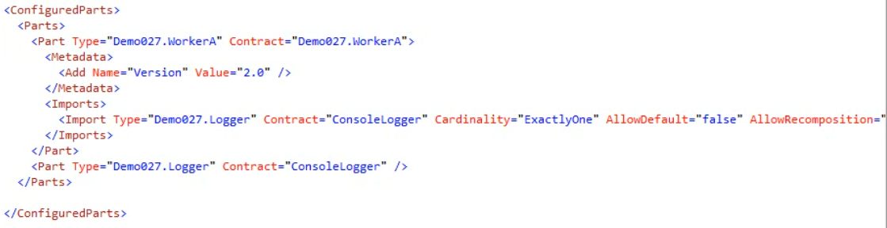

To declare and export, we add a new part element and setup the properties on it. For export, we define type and contract name. Metadeata is defined on a metadata element using key value notes. Imports are defined in the imports element as a child with the part. For imports, we define a lot of properties such as contract, cardinality etc.

These details will be deserialized into our configuredParts class where we can access them at runtime within our catalog. For this demo, we have setup a WorkerA part which imports a logger and a logger has a contract name of ConsoleLogger. As seen from the config, we have 2 parts – logger and workerA.

Out ConfiguredPartsCatalog class uses the ConfiguredParts in the constructor to build up a list of part definitions that we add to the parts collection.

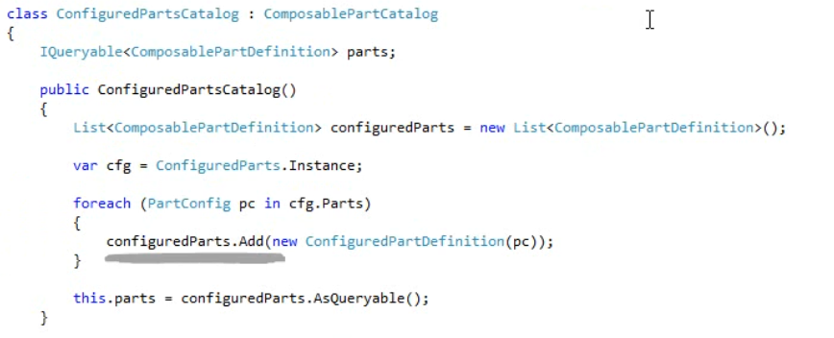

Because we are using our own discovery method, we don’t have to inherit from the existing catalog so, we are inheriting from composablePartCatalog directly which have overridden few things.

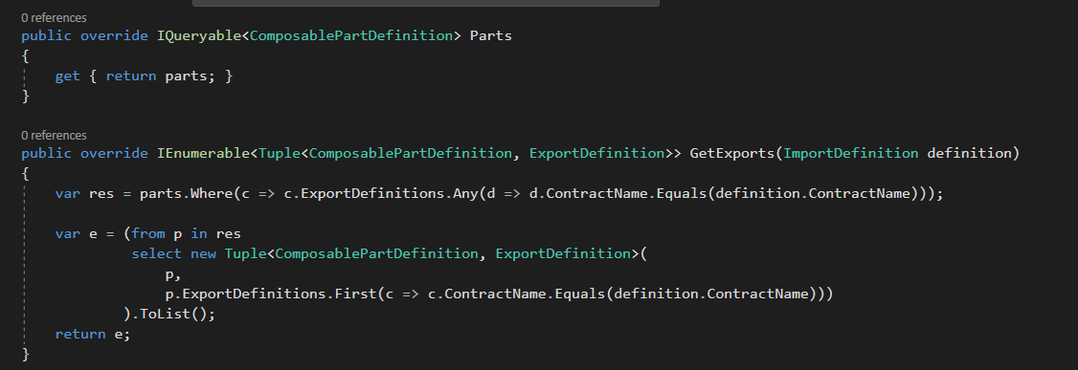

The above methods are part of the inbuilt class ComposablePartCatalog and since we are using our own discovery method, we are overriding these two methods of the inbuilt class.

In our constructor, we have a loop to find all the parts in the config file. For each one, we instantiate a new configuredPartDefinition with the details of the part we define in the config file. And then add it to the parts collection.

In the constructor for ConfiguredPartDefinition, we use a regular reflection to get the type info for the parts specified types, then we setup the exports and imports definition for the part.

For the export definition we create a new ExportDefinition using the contract name and then we have a helper method to initialize the dictionary for metadata.

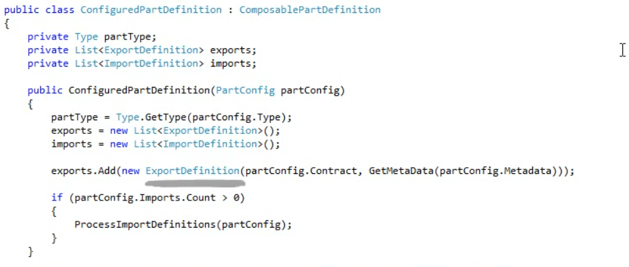

By default, we add an ExportTypeIdentity value set to the parts full type name. We will be using this later on. But it is also used by the container so, it kind of has to be there.

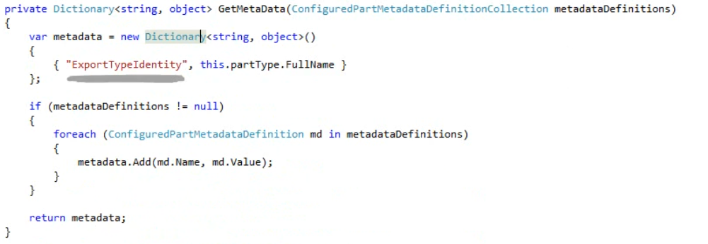

Also we call ProcessInportDefinitions from the constructor of ConfiguredPartDefinition class. This is also a helper method in the class in which we loop over each import defined in the config and setup a new import definition for it using to provide the contract, cardinality and so forth.

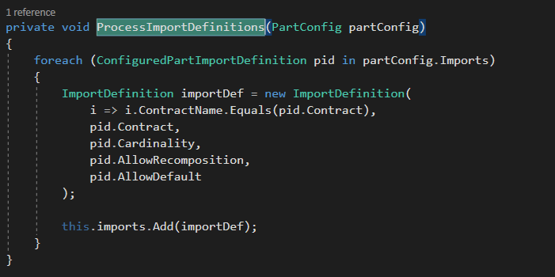

Since we are inheriting from composablePartDefinition, we have some overrides to take care of.

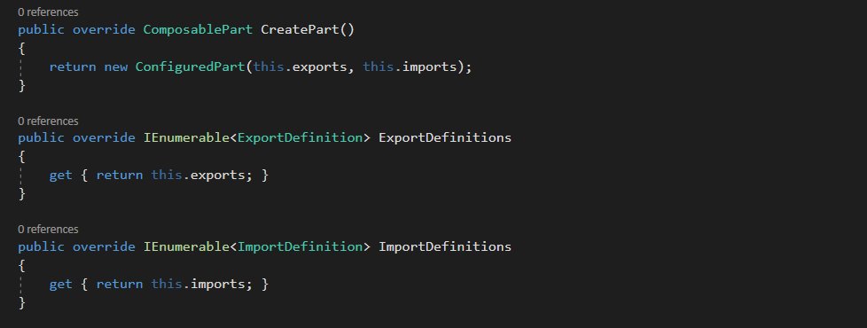

We have a CreatePart overridden method, which expects a composable part type to be returned. So, we oblige by returning the new instance of ConfiguredPart.

ConfiguredPart is the class where we will handle our scope. If we had a shared scope, we will return in an existing instance of the part. Since in this demo we are limiting ourselves to a non-shared scope, we are newing our instance each time.

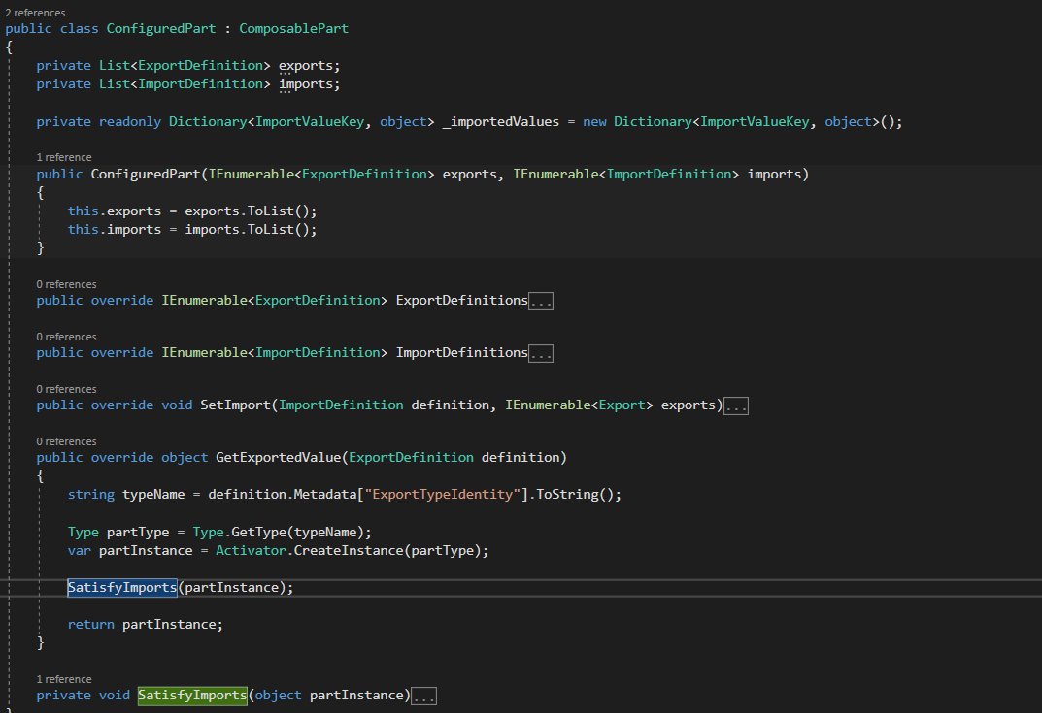

ConfiguredPart constructor just sets the export and import definitions. Again as we are inheriting from ComposablePart class we are overriding few methods here for our needs.

The ExportDefinitions and ImportDefinitions just return s the exports and imports list.

The SetImport method gets call for each import the part is defined. In the parameters we get the import definitions and a collection of exports. The import definition will tell us things like contract, type and cardinality, the exports in the collection will be the potential matches for the import. This method is where we verify the cardinality rules to make sure we get what we are expecting. For limiting the complexity of this demo, we are limiting it to ExactlyOne.

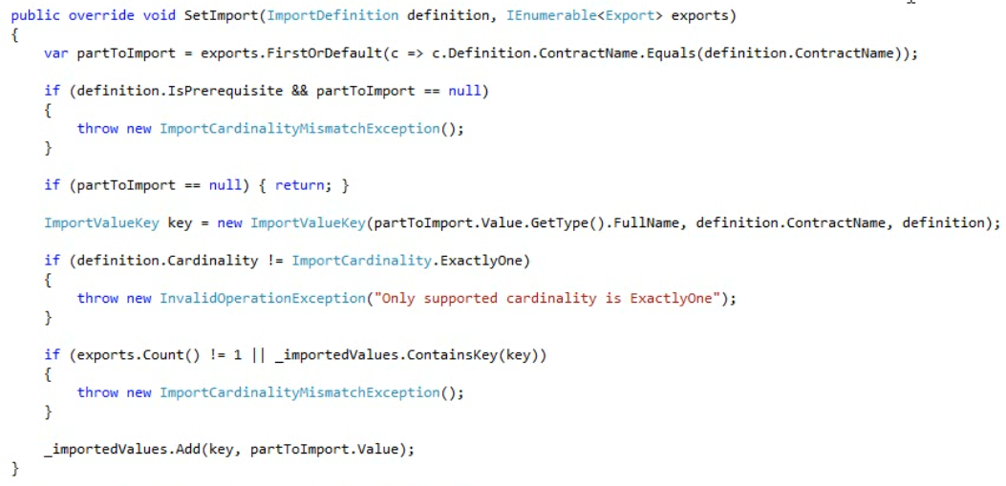

First we are querying the exports to match on the contract name of the import. If the prerequisite, meaning it does not allow default values, and no matching export is found, we throw a ImportCardinalityMismatchException.

Otherwise, if the part is null and there isn’t a prerequisite then we will return without doing anything.

If a match is found, we will set up a new ImportValueKey which is just a nice way for creating a key for our part using the type and contract.

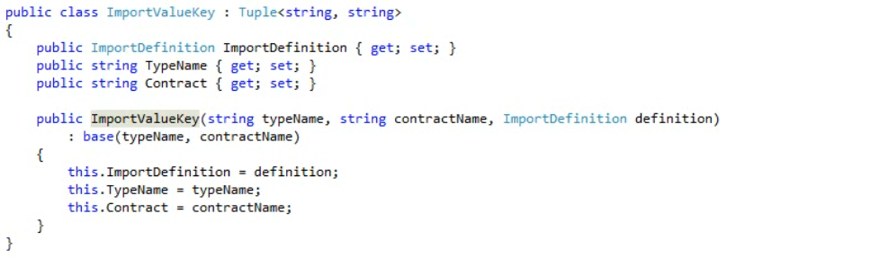

At the top of our ConfiguredPart class, we have a dictionary that uses the ImportValueKey type for the key and an object for the value type. We use this to store instances of exports that will be used to satisfy imports.

We check to make sure that the cardinality is ExactlyOne, if not, we throw an exception.

Then we check and make sure we don’t already have an instance in our dictionary, if we do then it means that we have a cardinality mismatch.

If everything goes as per the plan, we will add the export instance to our dictionary for later retrival.

Finally we have a GetExportedValue method, which takes in an exportDefinition. This method is used to build and compose a part instance, so we use a bit of reflection here by getting the type from the metadata and then using the activator to instantiate an instance of that type. Once we have a part instance, we need to make sure that we satisfy its imports. So we make a call to the SatisfyImports and then return the partInstance which we fully composed.

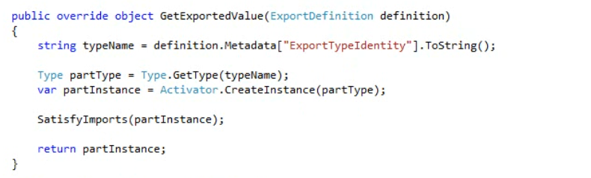

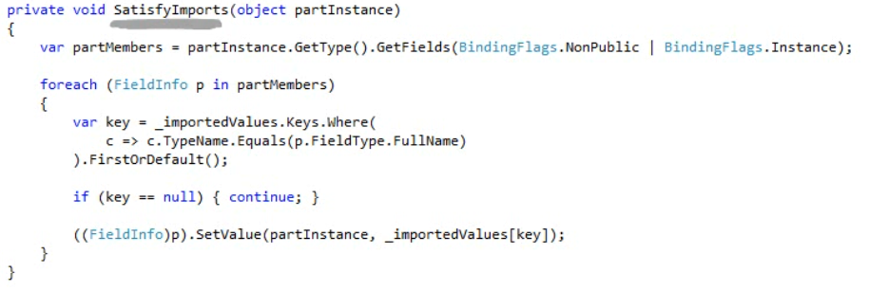

In the SAtisfyImports method, we again use reflection to find all fields in the part type and for each field found, we check our imported values dictionary for any matches on that type. If any are found, er set the field to the instance of the part from our dictionary.

If you remember, multiple programming model can be used with MEF, to approve that, I have setup and attributed part that also imports logger. But remember, Logger is not an Attributed part.

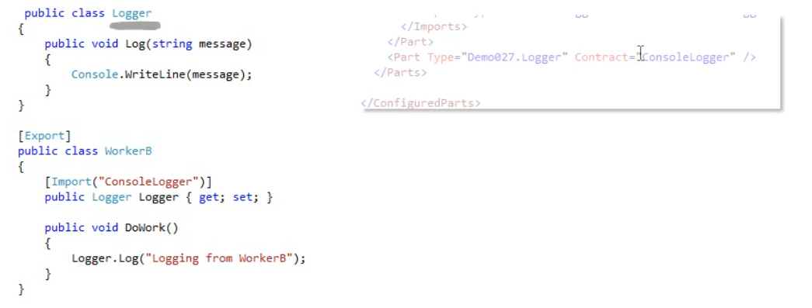

We are telling MEF about the Logger in the config file using our own programming model.

Finally this is our main method.

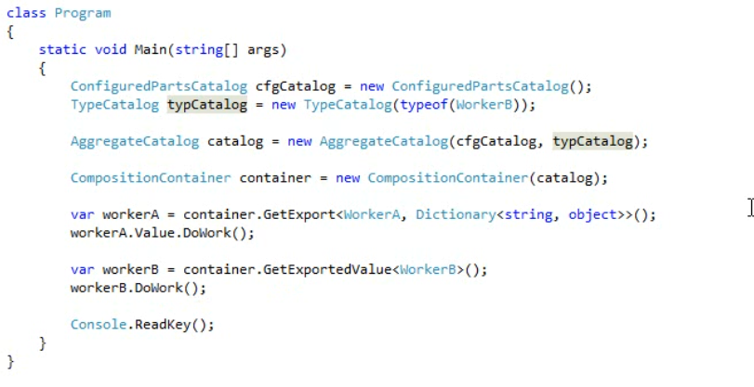

When we run this, we get the below output.

